**SOFTWARE DEVELOPMENT PROJECT**

**2019-2020**

On

“ONLINE APPOINTMENT MANAGEMENT

SYSTEM”

**Developed by:-**

( Group no :- 9)

Roll No :- 17BCA073 Mr.Madhav Parikh

Roll No :- 17BCA128 Ms.Vini Paul

Roll No :- 17BCA137 Mr.Bhupender kumar

**(Semester VI–Bachelor of Computer Applications)**

**ACKNOWLEDGEMENT**

We wish to express our gratitude to all the people involved in contributing this project of our website “Online Appointment Management System”. We take this opportunity to thank all who have helped us during the project work.

We would like to thank our college, St. Xavier’s College (Autonomous) for providing us the opportunity to work on project and gain experience from the same. We present our heartful thanks to the Vice Principal **Dr. (Fr.) Johnson Mundupuzhakal** for sharing his generous time and knowledge with us which helped us to complete this project on time and present it to the examiners.

Genuine thanks to **Ms. Nithya Nadar**, our internal guide for her critical reviews of the project which help us to make this more presentable. Her gentle support and direction guided us in all aspects of the project. It has been pleasure to work with **“Odoo India(Tiny ERP Pvt.Ltd)”,** and we appreciate the cooperation of the staff. Our special thanks to the external guide **Mr. Mantavya Gajjar** for his kind review of the project.

We would also like to thank all the faculty members of **St. Xavier’s College (Autonomous)** for their tangible, but always unspoken support for this project.

Last but not the least we would like to express our sincere thanks to our parents for their precious support and their motivation for completing this project.

Yours Sincerely,

Madhav Parikh 17-BCA-073

Vini Paul 17-BCA-128

Bhupender Kumar 17-BCA-137

**INDEX**

SR NO. TOPIC PAGE

1) INTRODUCTION……………………………………………..01

2) SCREEN LAYOUTS……….………………………………….02

2.1) ADMIN SIDE VIEW……………………………………..07

2.2) CONSULTANT SIDE VIEW…………………………......18

2.3) USER SIDE VIEW…………………………………….......38

3) REPORT LAYOUTS…………………………………………...56

4) CONCLUSION.....………...…………………………………....64

5) BIBLIOGRAPHY ………………………………………………65

**INTRODUCTION**

Our documentation for the project “Online Appointment Management System” involves screenshots of the screen layouts and the report layouts of the system.

We have documented the screen shots which were taken while running the website. The screen shots contains all the views of our three entities which are Admin ,Consultant,User.

The documentation further contains the screenshots of the reports which can be generated by the admin for analyzing the data.

Lastly, we have given the conclusion of the OAMS(online appointment management system).

Towards the end of the documentation are mentioned the books or websites we referred during the completion of our project so far.

**Screen layouts**

**MAIN PAGE**

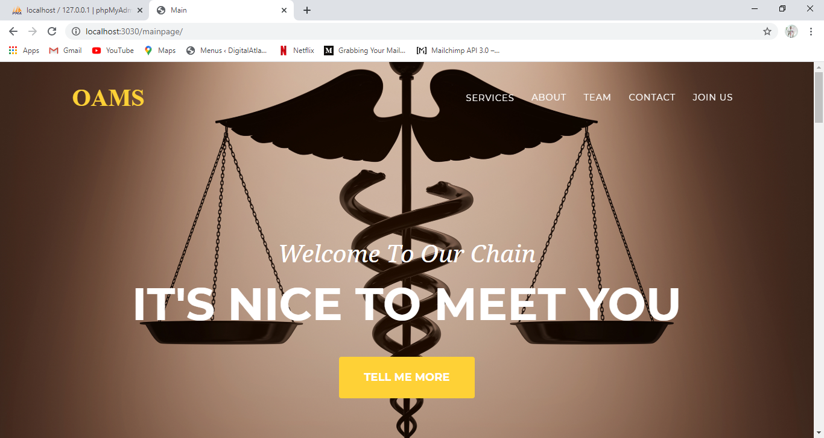

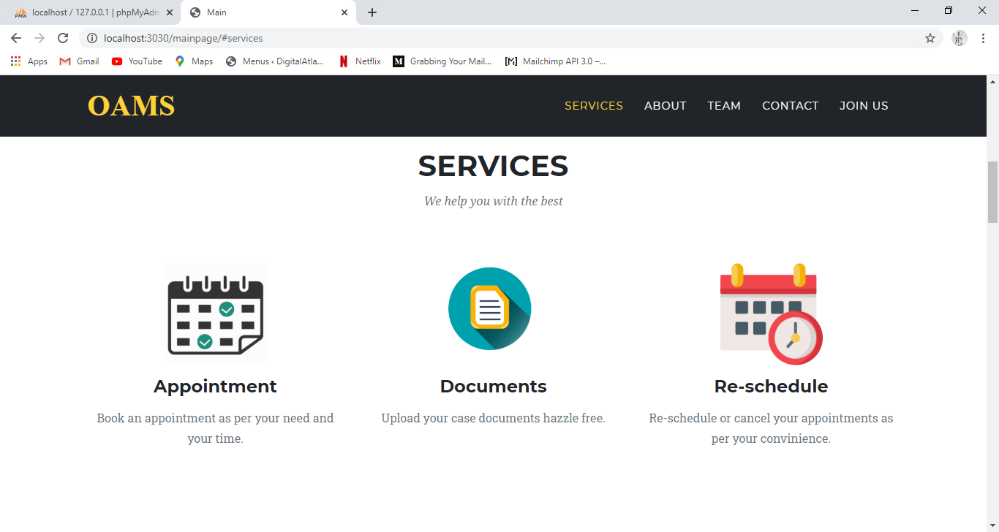

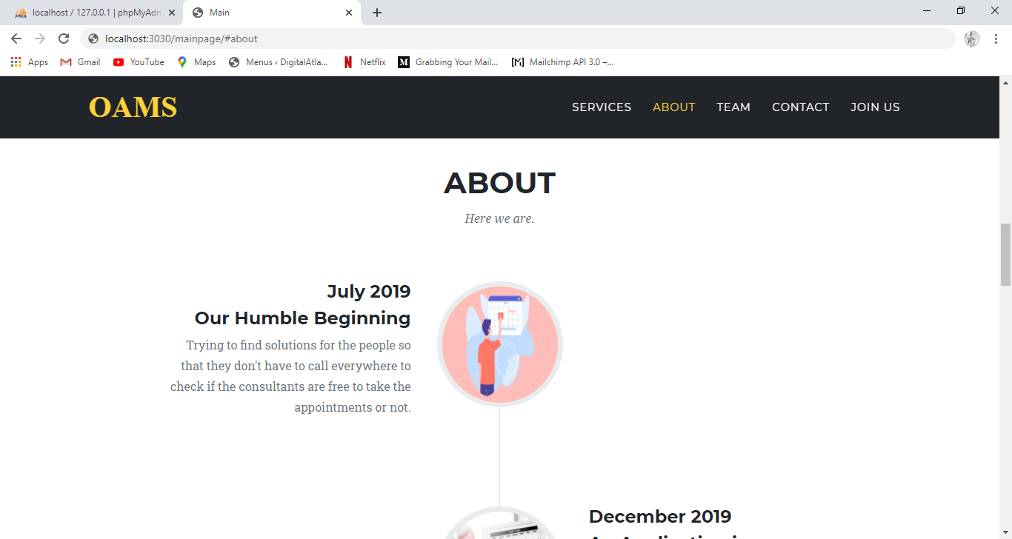

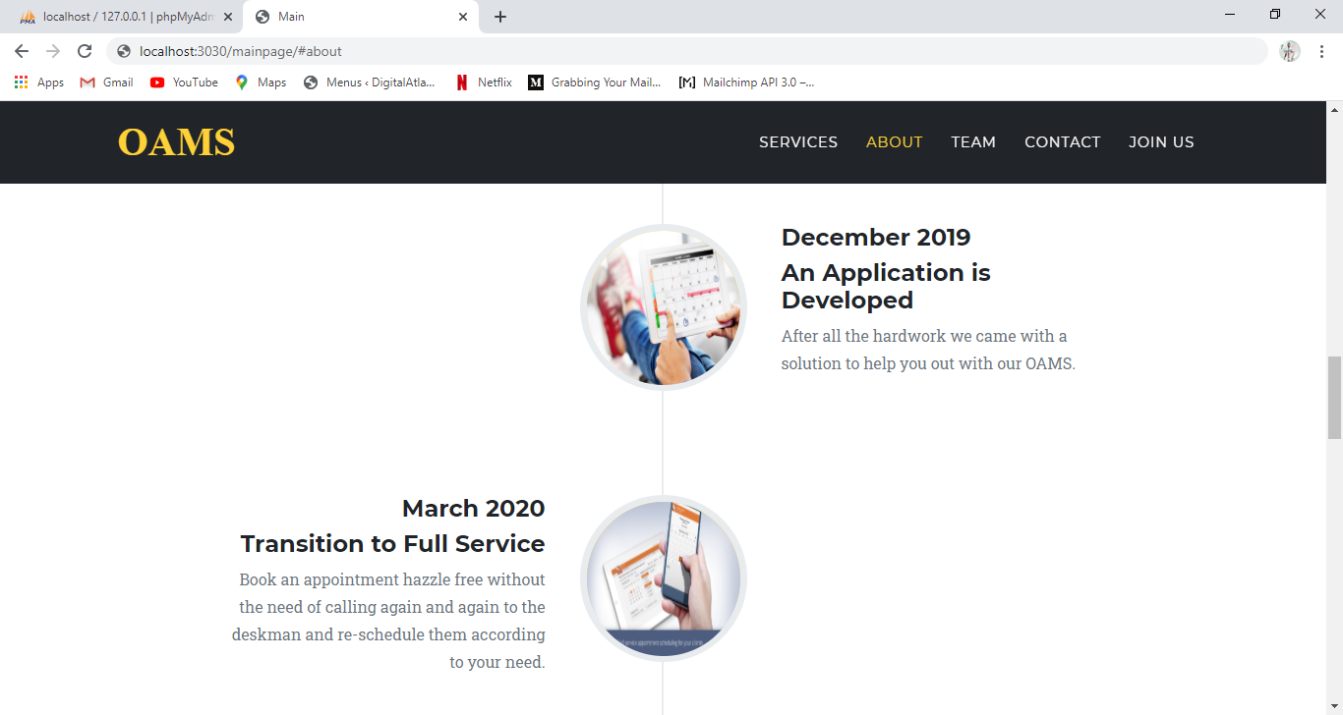

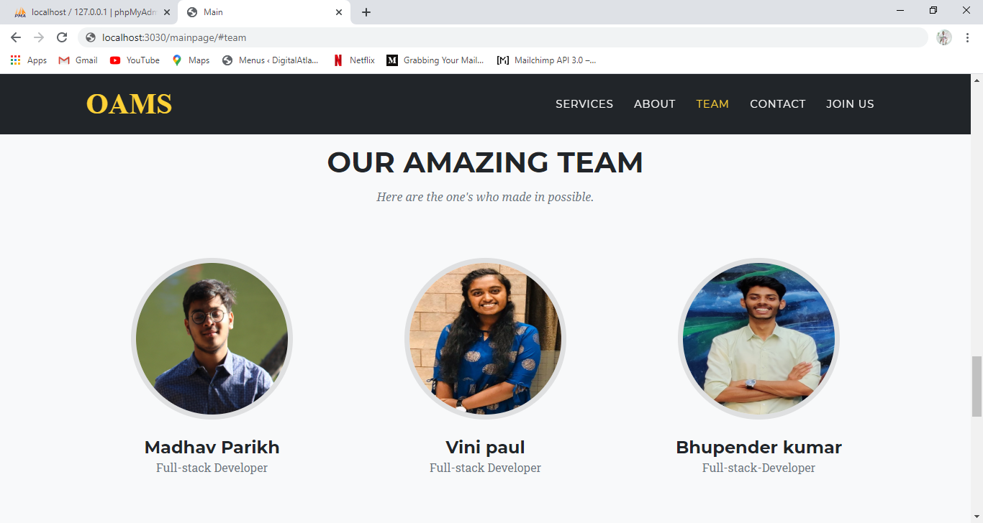

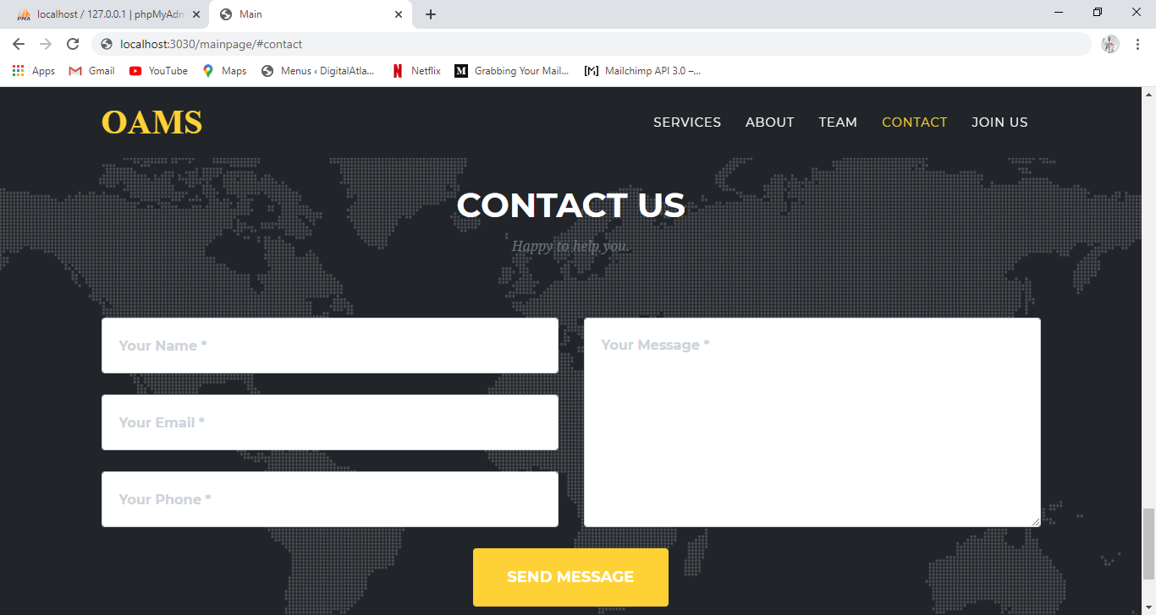

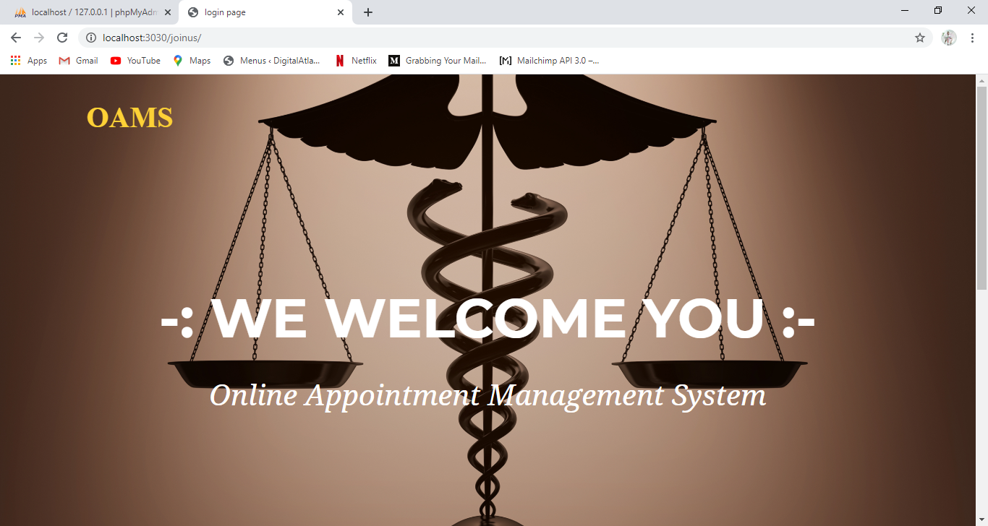

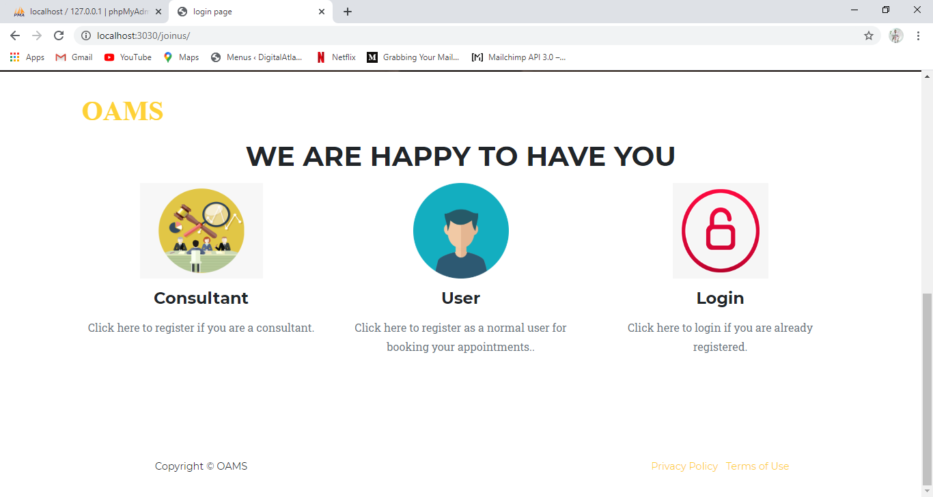

**ADMIN SIDE**

**LOG IN PAGE**

Admin login form helps admin to login using email id/mobile no. and password.

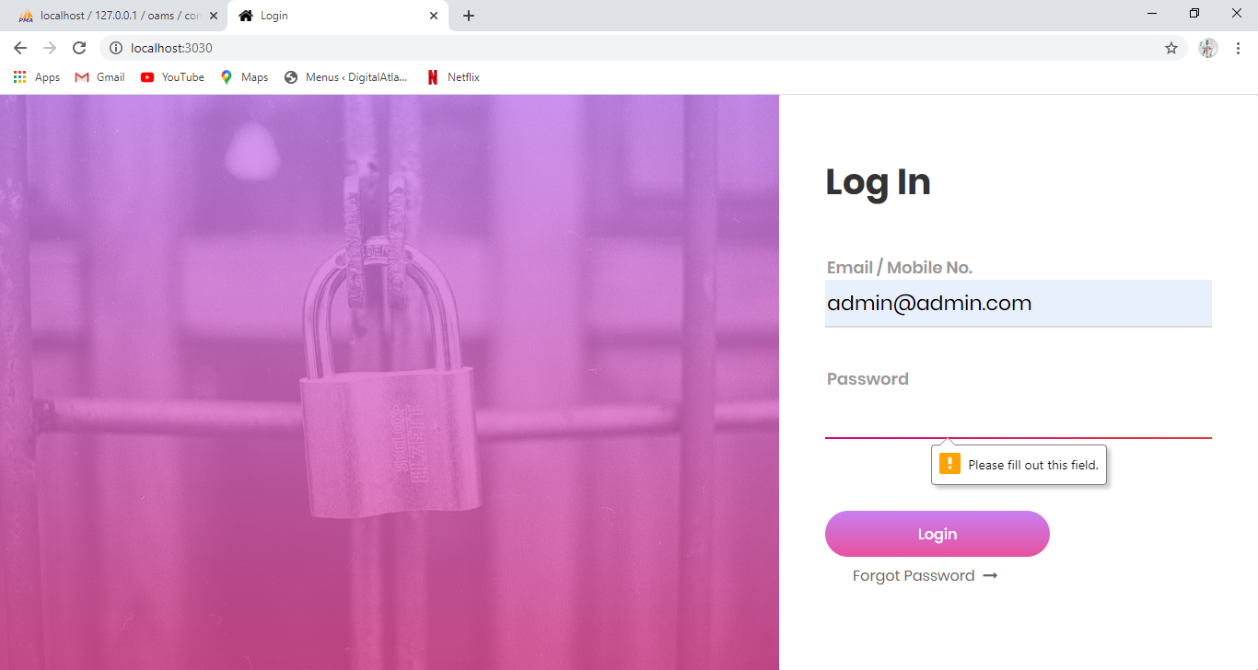

Email id Field Should not be empty. Email id should match the requested format which contains @ and (.)

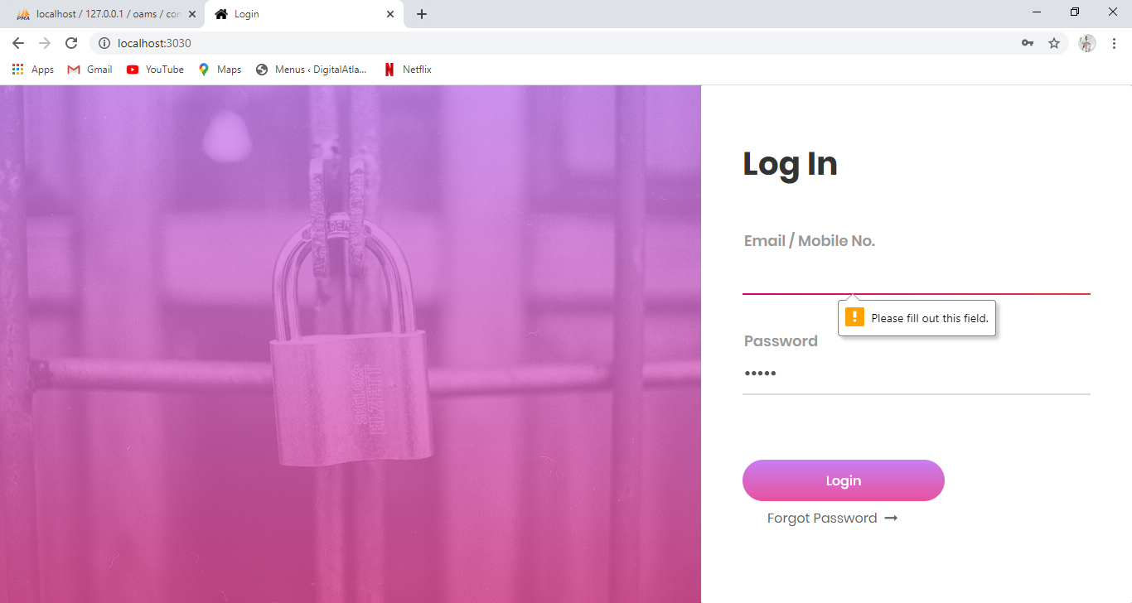

**ADMIN DASHBOARD**

Update Password form is used to set or update password. By entering password and clicking update password button, password will be updated.

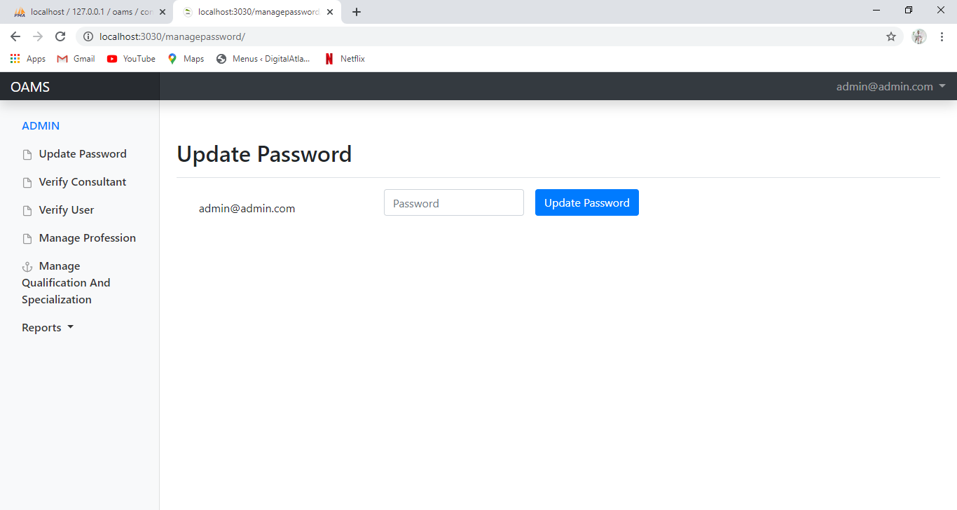

**List of consultant**

Verify Consultant form displays consultant's required details like name, email id, phone no., profession, PAN card and GSTN.

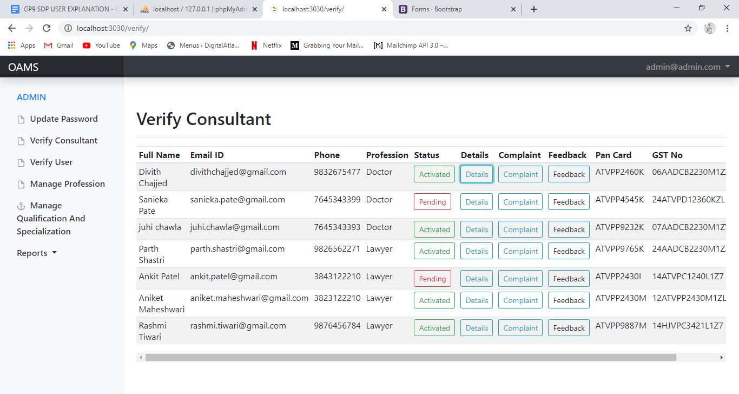

In accordance with these details admin will verify and authenticate the consultant.The authenticated consultant will have double clicks on the verified columb. By authenticating the consultant, status will be changed into activated and consultant will receive an approval email or else status will remain pending.

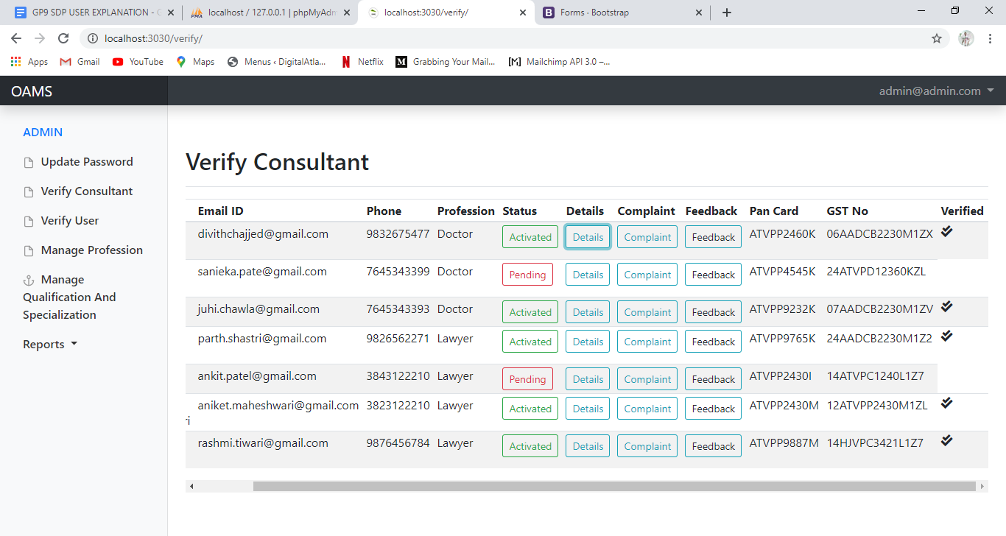

**Consultant Schedule**

Admin can view consultant's schedule details using details button.

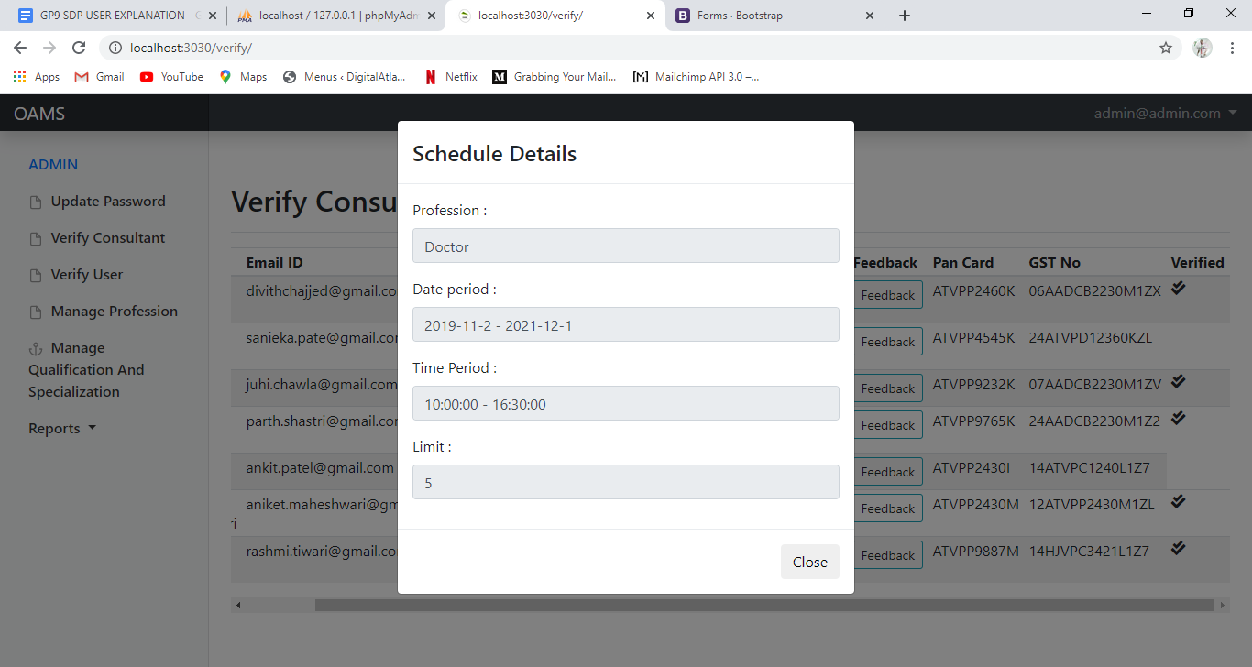

**Feedback of consultant**

Admin can also view user ratings using the feedback button.

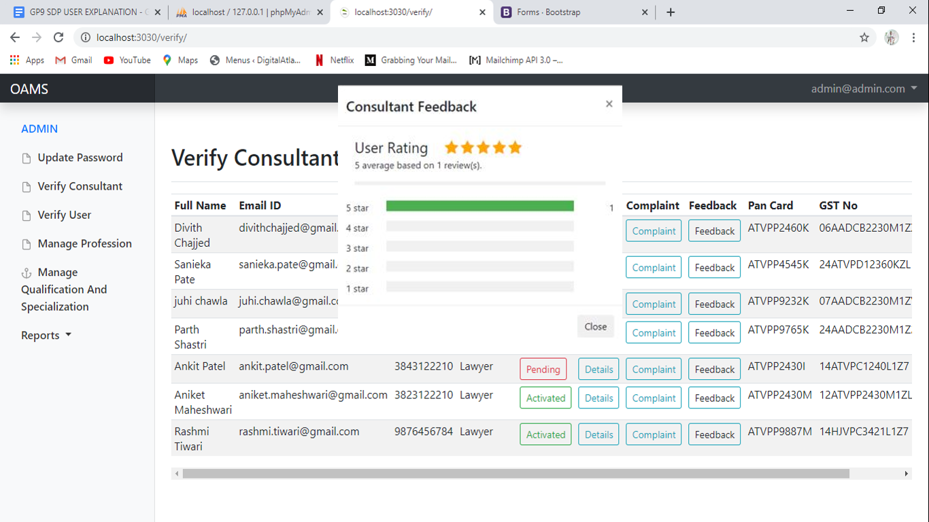

**complaints of consultant**

Admin can also view the complaints registered on the consultant using view complaint button. Further, admin can take necessary actions accordingly.

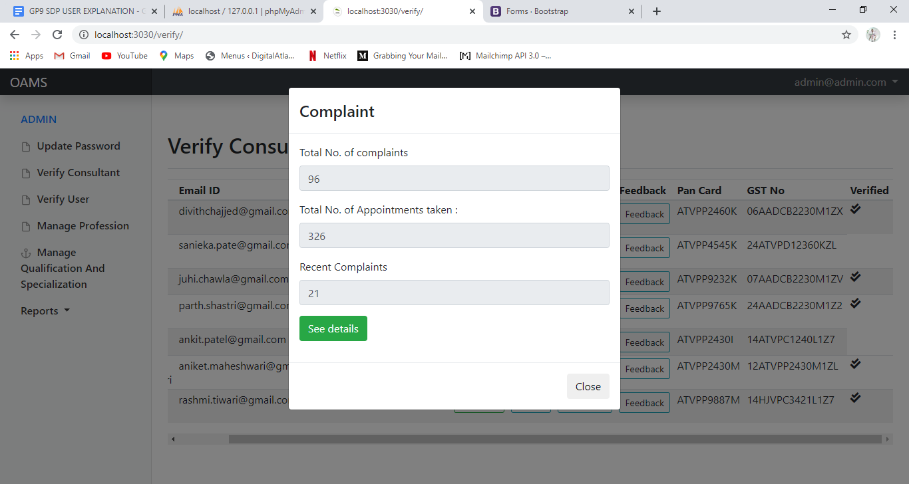

Admin can see the Details of the comaplints registered on the consultant by clicking see details button in complaint moddle..

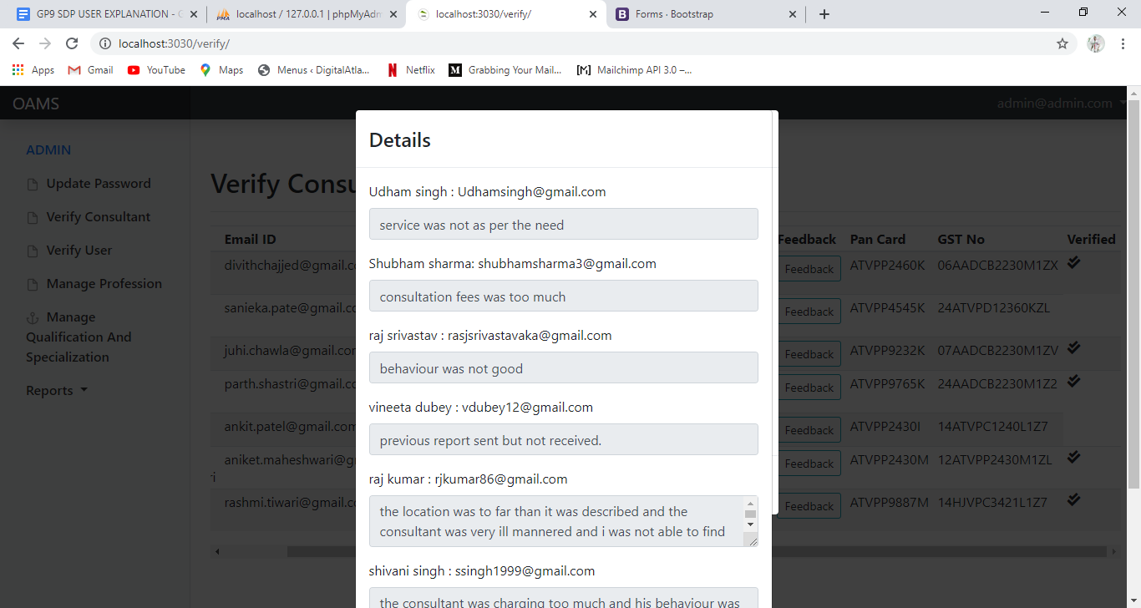

**List of user**

Verify User form displays the list of user and the list contains user's name, email id and phone no.; in accordance with these details once the user is verified status will be changed into activated or else status will remain pending.

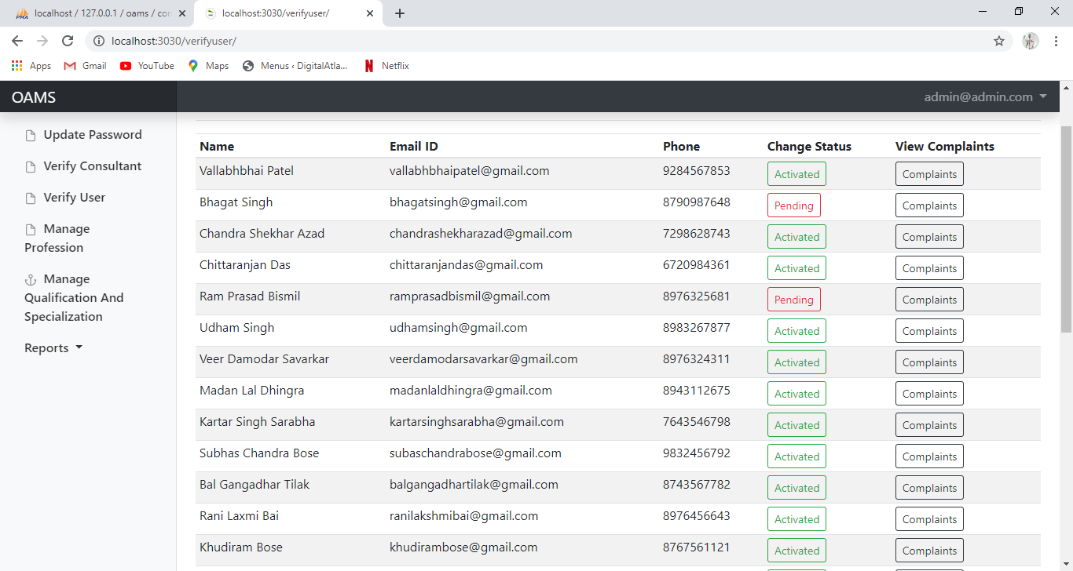

**Complaints on user**

Admin can also view the complaint registered against the user by clicking on the complaint button.

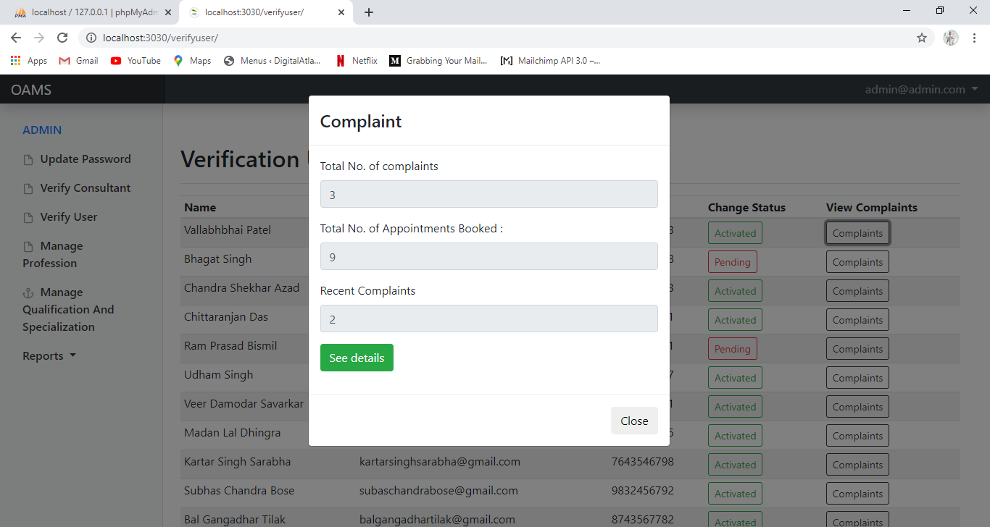

Admin can see Details of the complaints registered on the user by clicking the see details button .

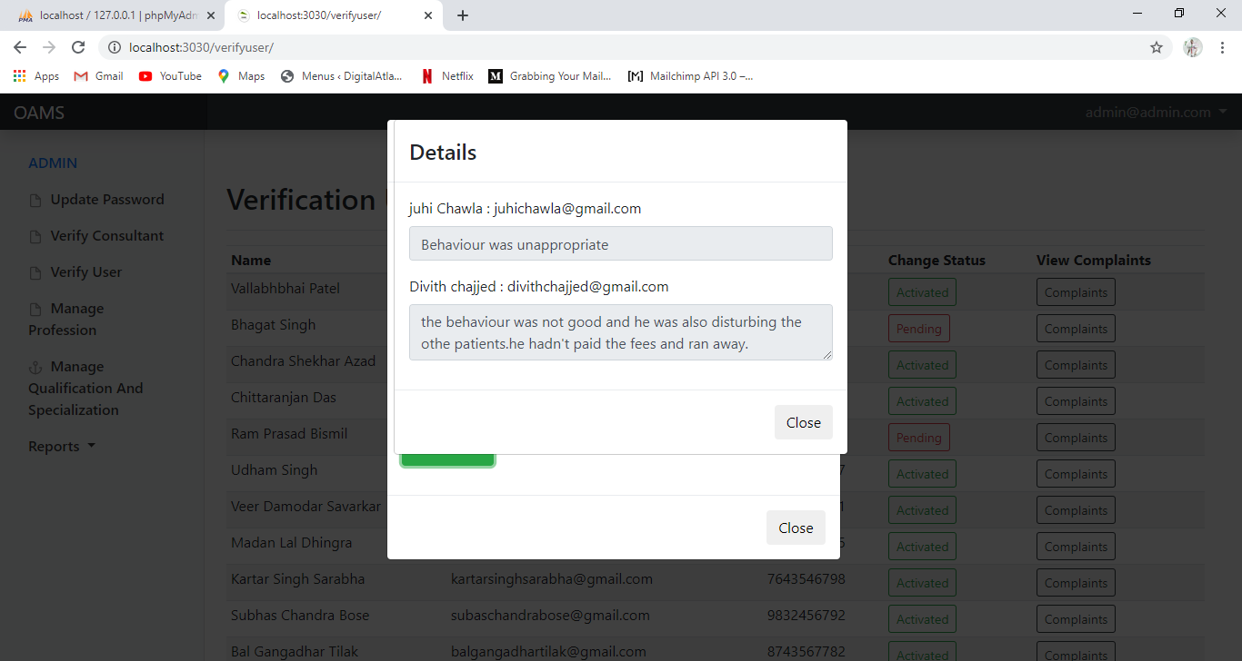

**Manage profession(Add,update and delete the profession details)**

Manage Profession form is used by admin to add, update and delete the profession details as per the requirement. In this form profession type and id will be updated; update and delete buttons are used for the updations.

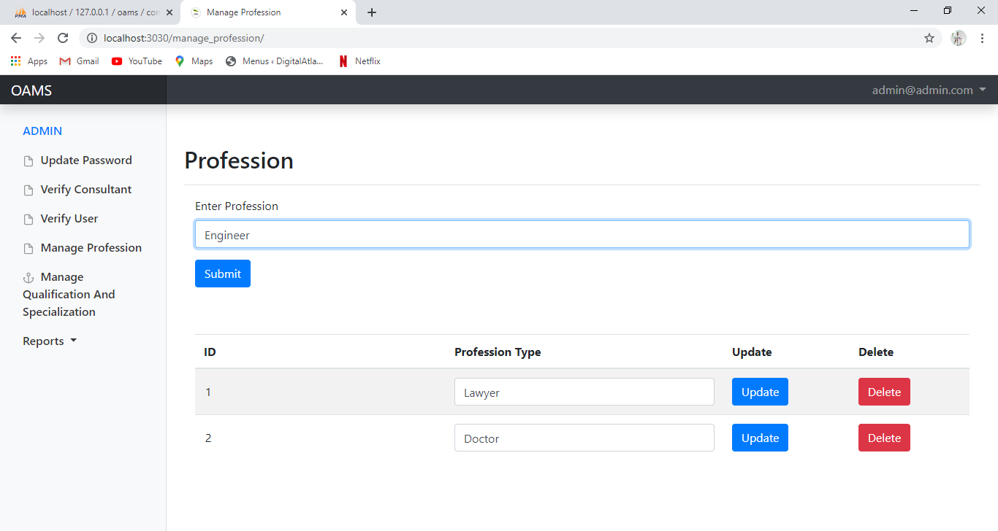

**Manage qualification and specialization (add,update and delete the details)**

Manage Qualification and Specialization form is used by admin to add, update and delete the qualification and specialization details for the respective profession.By selecting profession and entering the details of qualification and specialization; update and delete buttons are used for the updations.

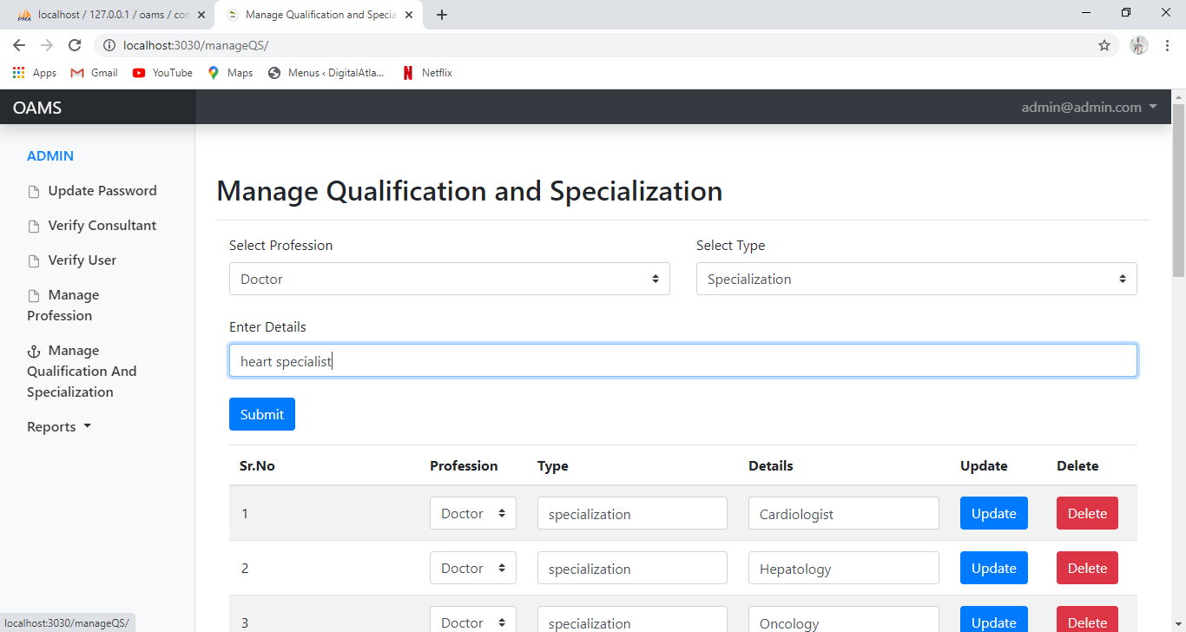

Reports option displays various reports on the basis of Profession, appointment, area, date, experience, feedback and specialization; filters are used to display the entries; reports are generated by selecting the required details from the dropdown list; reports can also be downloaded.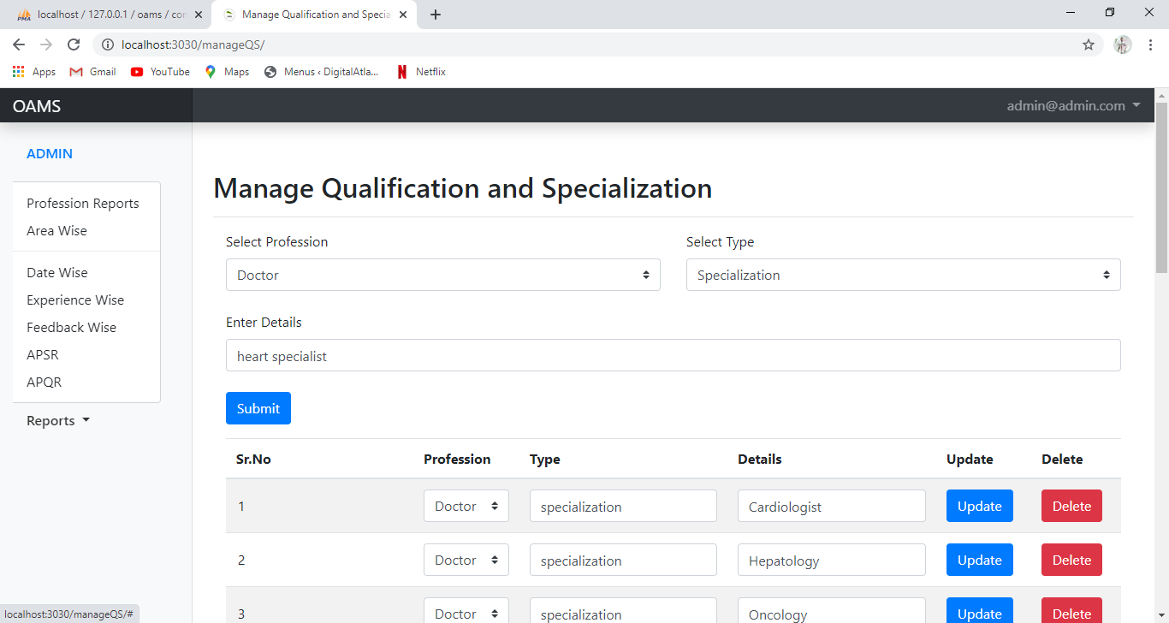

**Reports (generation and downloading of reports)**

Admin can generate the reports by selecting the desired criteria.

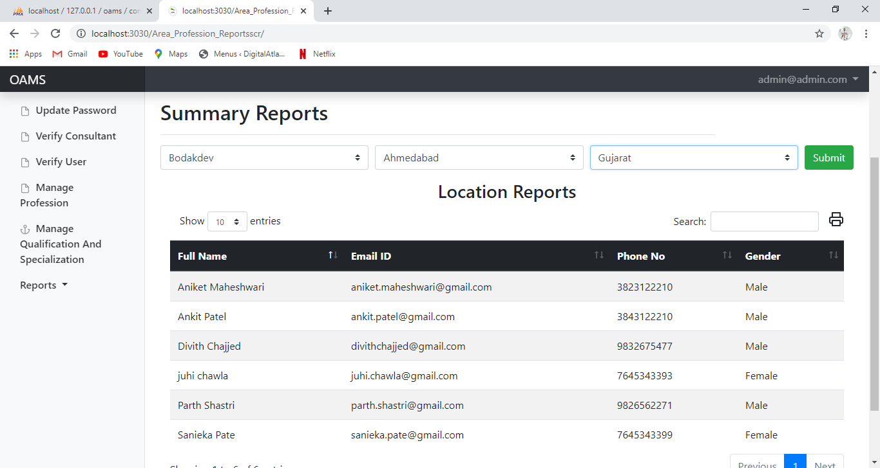

Admin can choose the no of records he wants in a particular report.

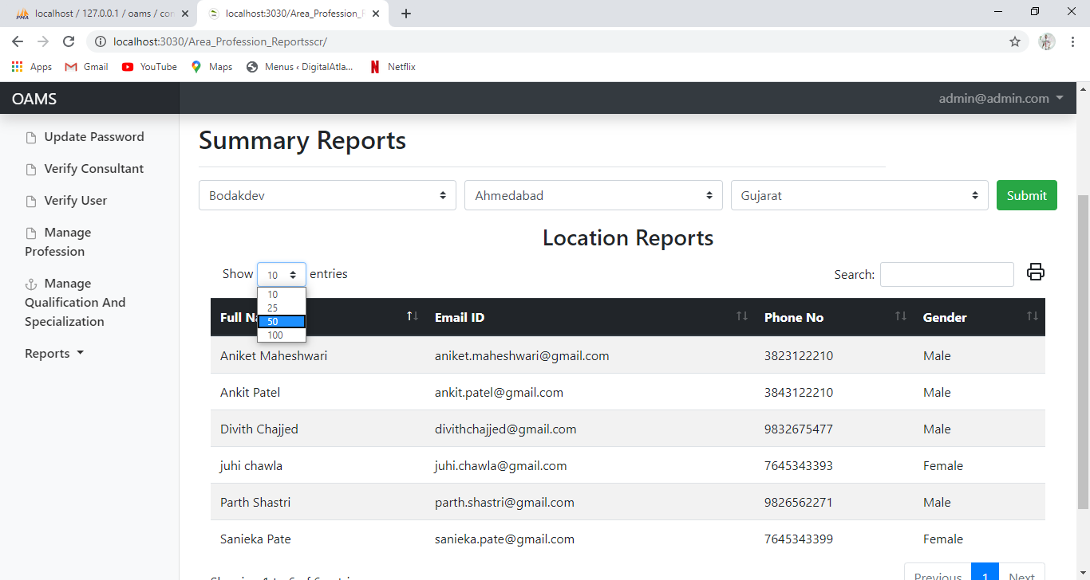

**Printing layouts of the reports**

Printing layout of the report after clicking on the print button.

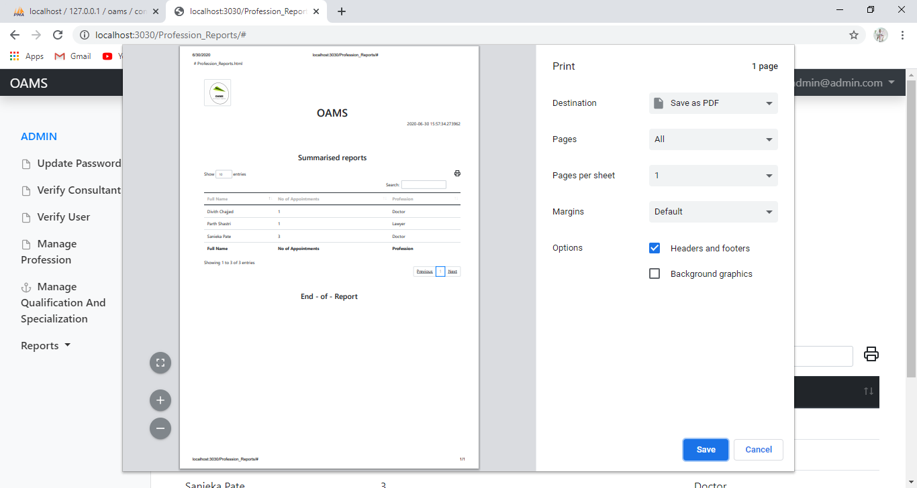

Report layout after being downloaded.

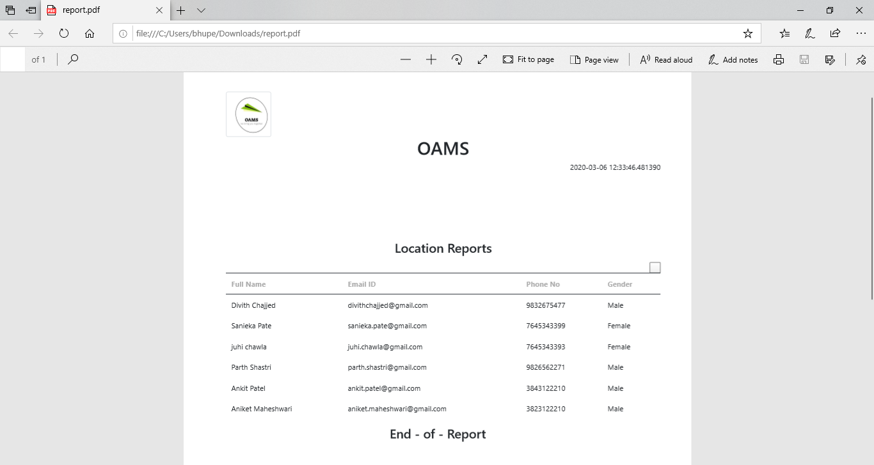

**CONSULTANT SIDE**

**CONSULTANT REGISTRATION**

Consultant Registration form helps consultant to register his basic as well as professional details as per the requirement

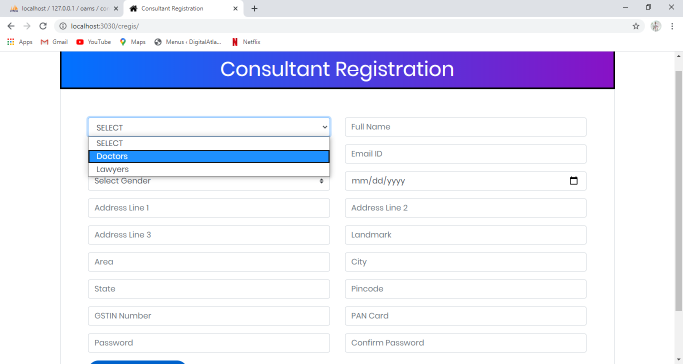

On the basis of profession selection from the dropdown, its respective qualification and specialization will be provided to the consultant

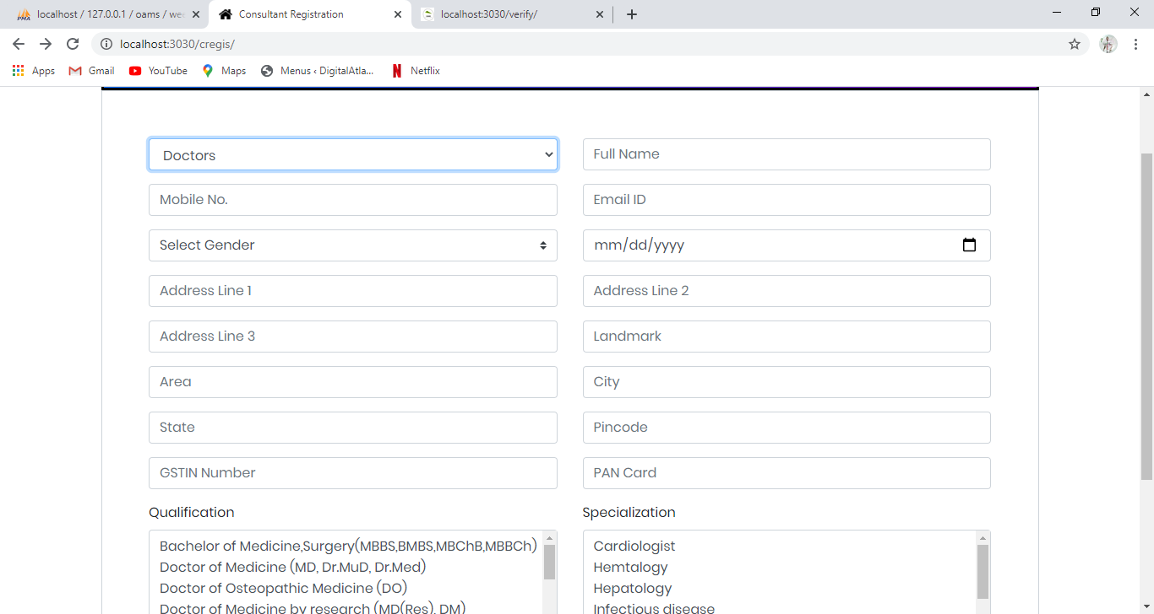

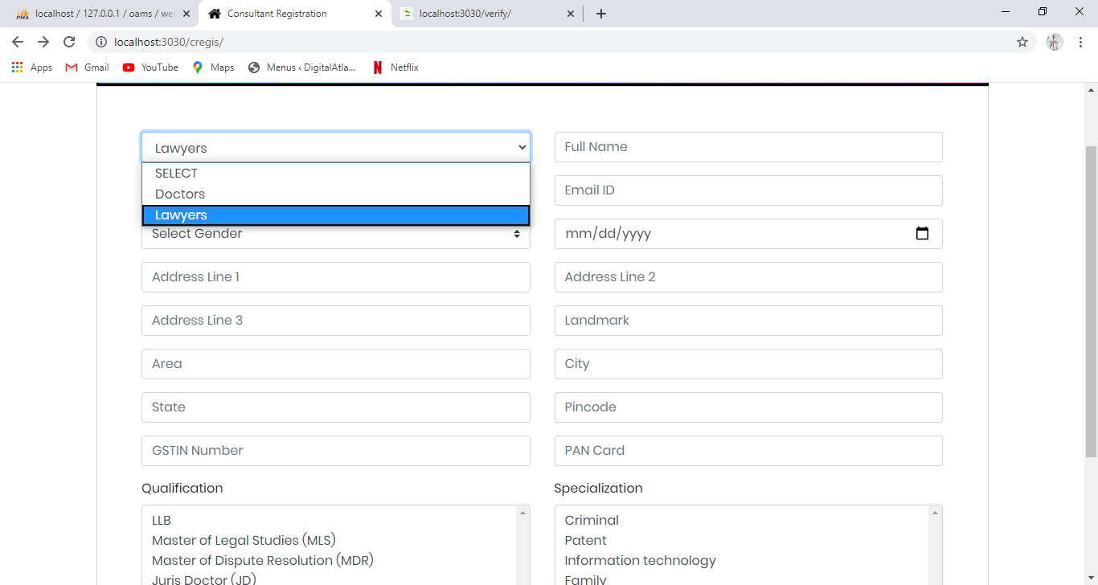

Name field should not be empty and should not be in digits.

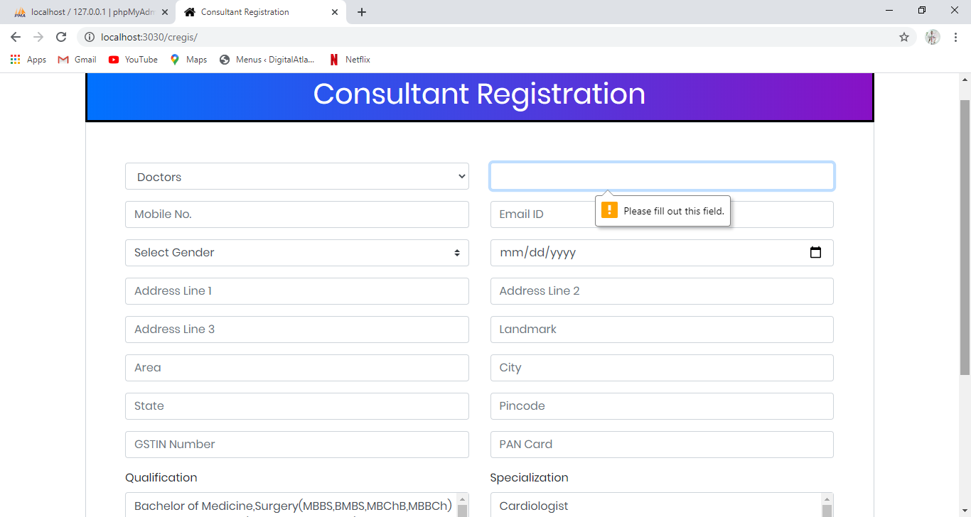

Mobile no. should match the requested format , it must be in digits.

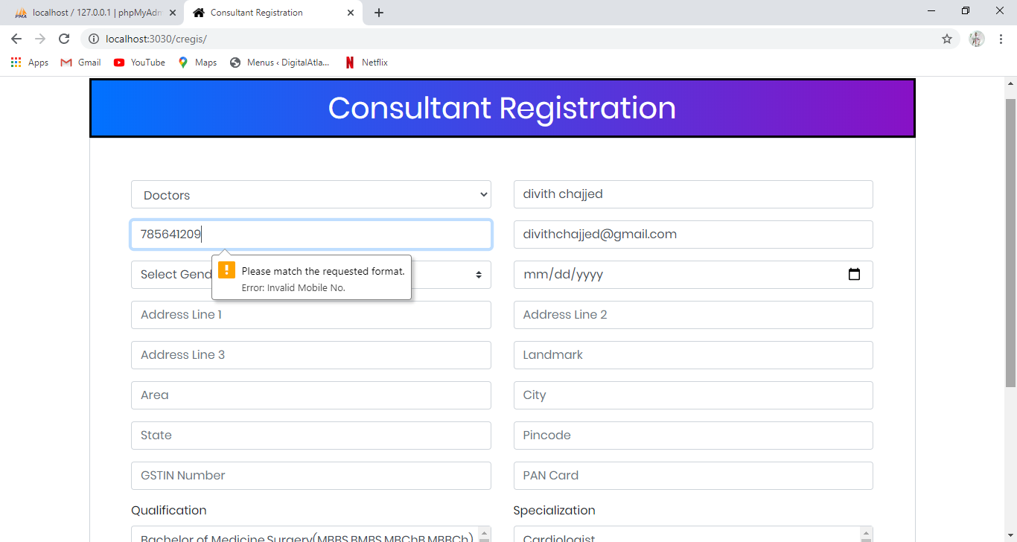

Email id should match the requested format which contains @ and (.)

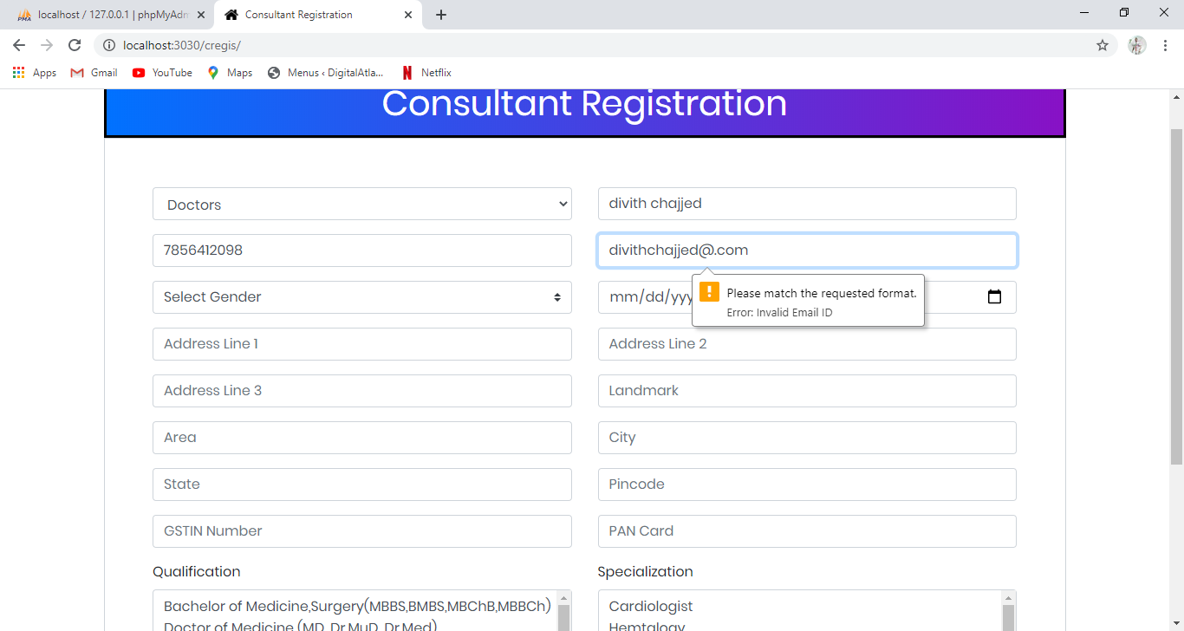

Date of birth should be greater than 21 for the consultant.

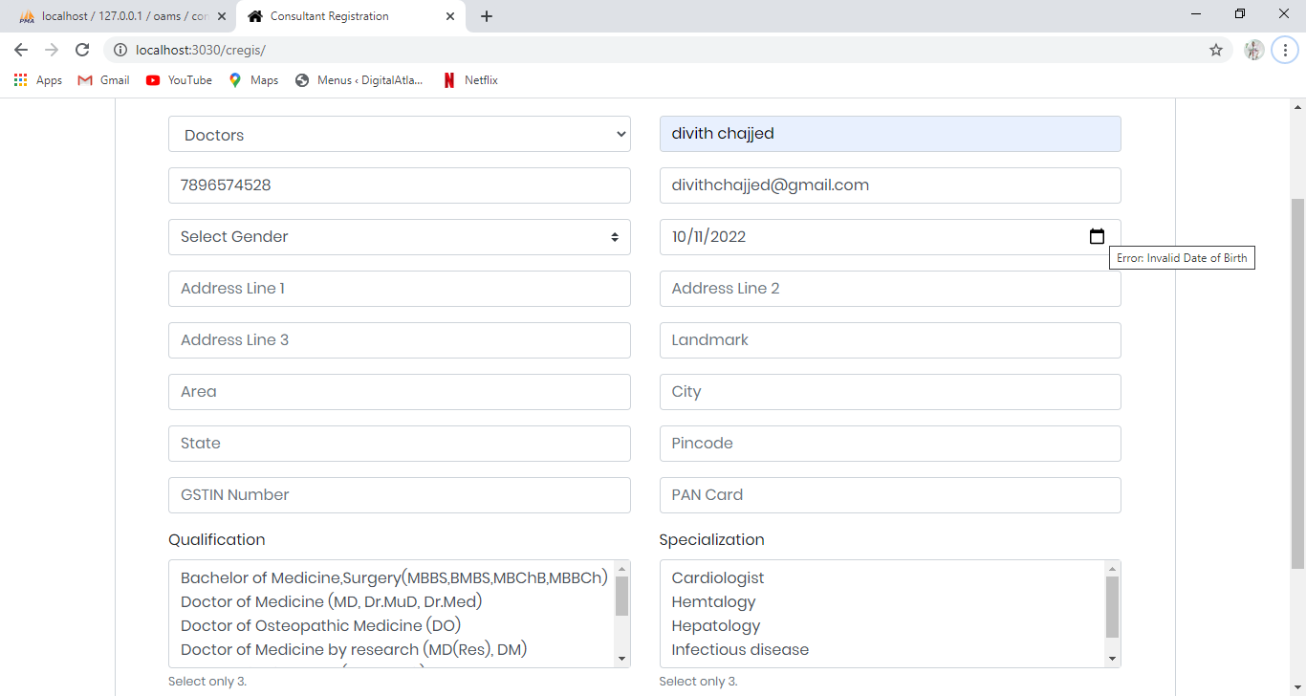

Address field cannot be empty. The pincode and the area should be valid

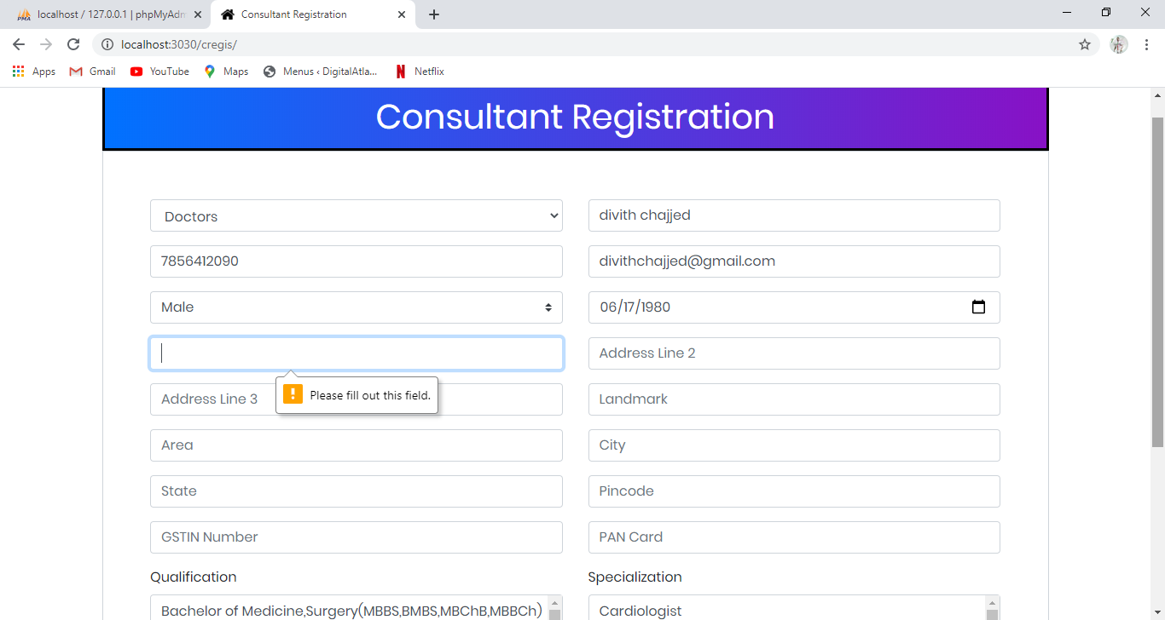

For the verification purpose PAN and GSTN number is asked to enter and it should match the requested format

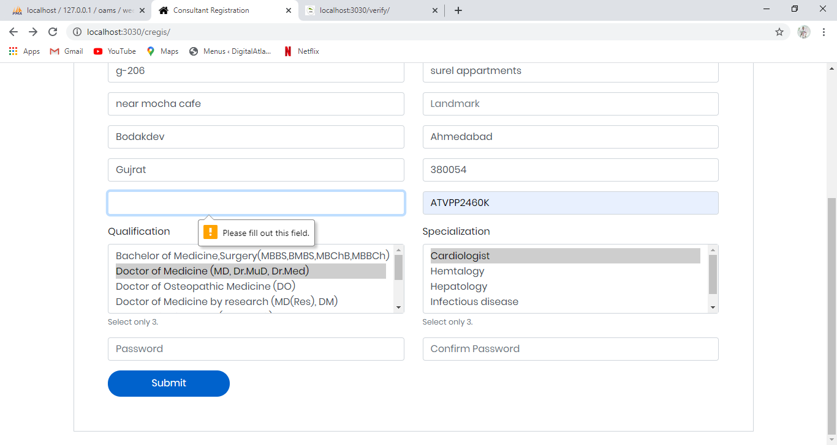

**Email received by the consultant after registration**

Email received by the consultant after the registration process is completed and the details of his PAN card and GSTIN no has been verified by the Admin.

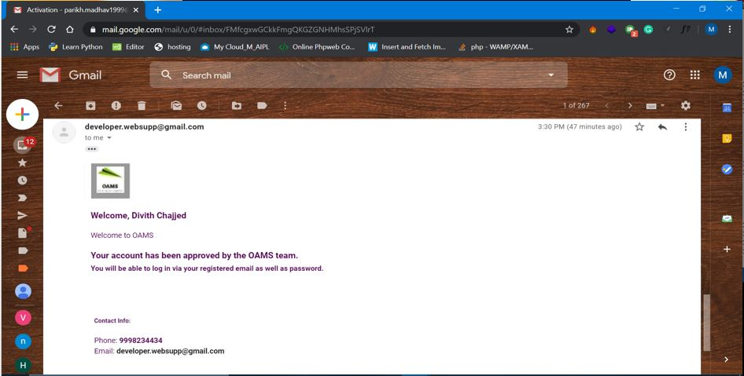

**CONSULTANT LOGIN**

Consultant login form helps consultant to login using email id/mobile no

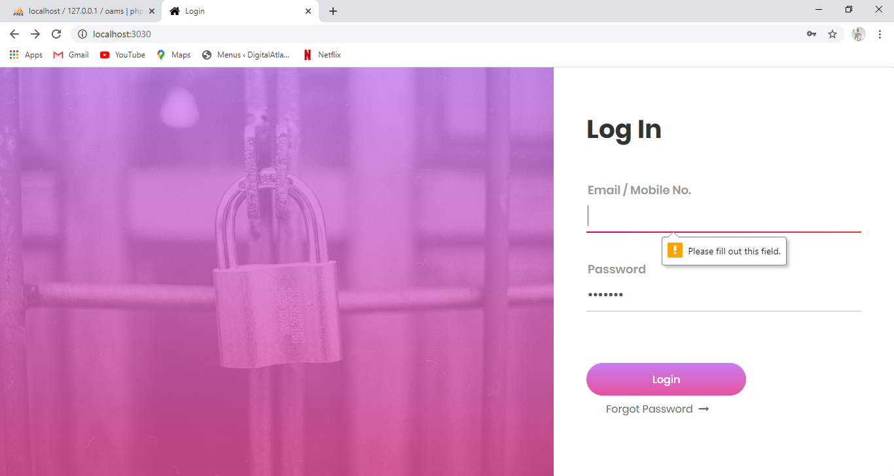

Consultant should enter the password which has been entered during registration process.

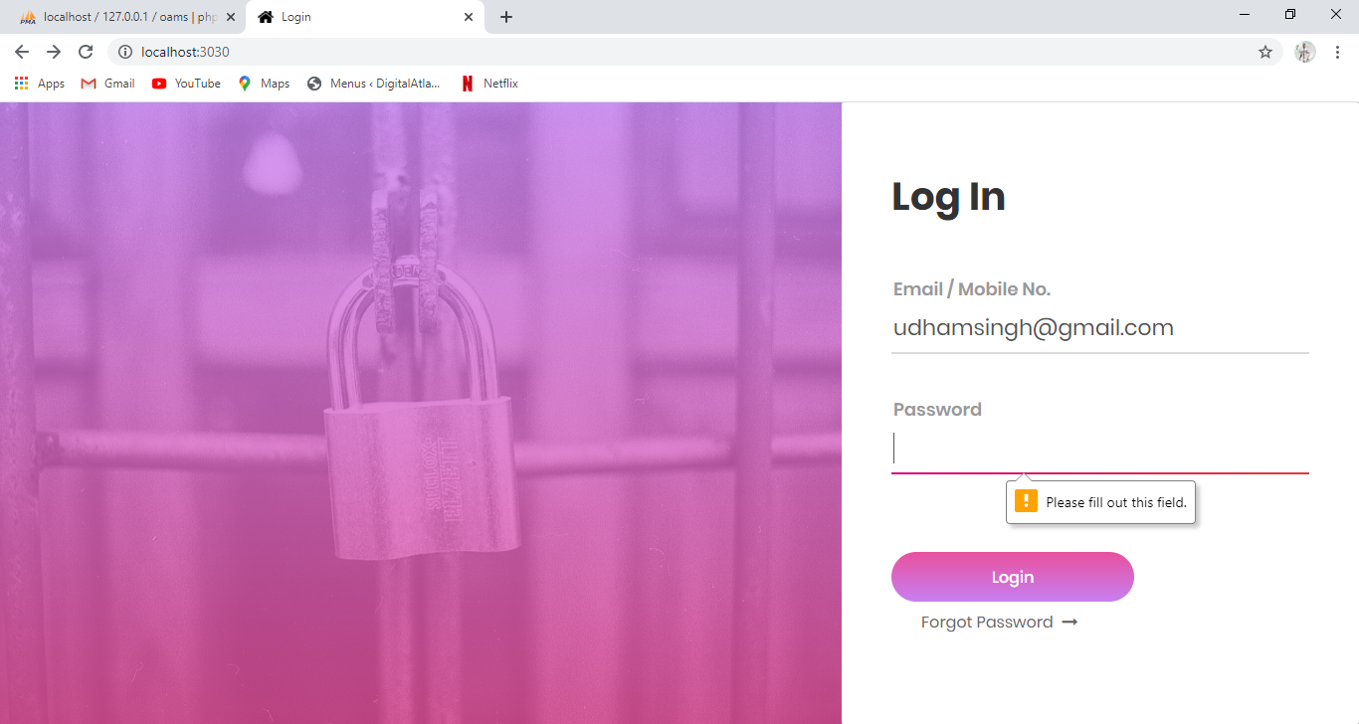

Email id should match the requested format which contains @ and (.). Mobile no. should match the requested format, it must be in digits. These details should match the details entered in registration form or else won't be able to login.

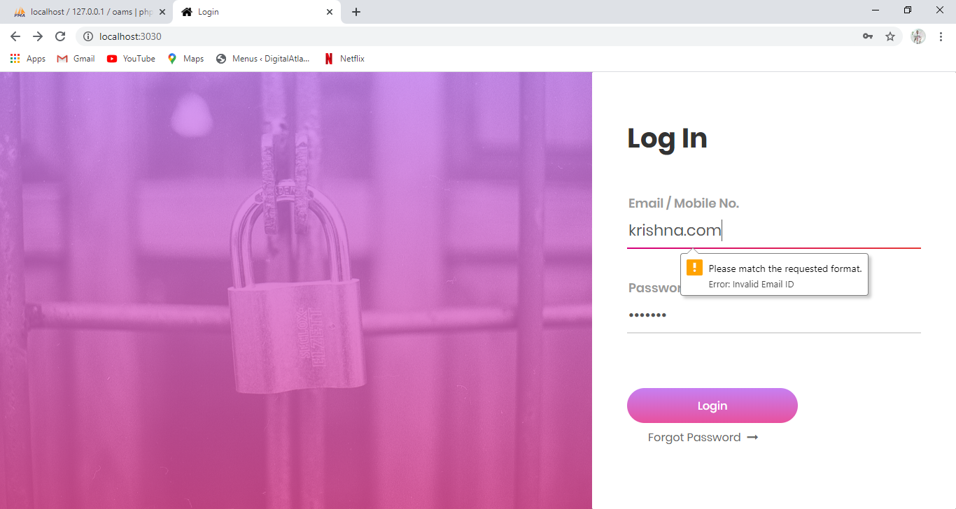

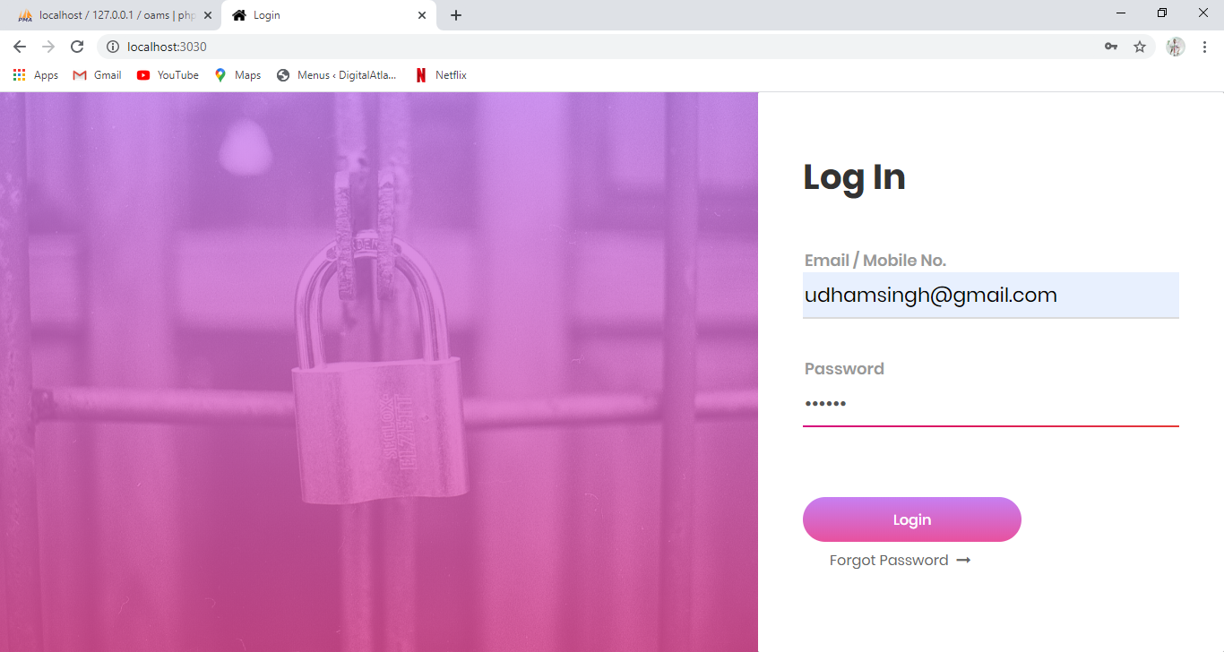

If the consultant is unable to remember his password, he can click forgot password button and further submit email id

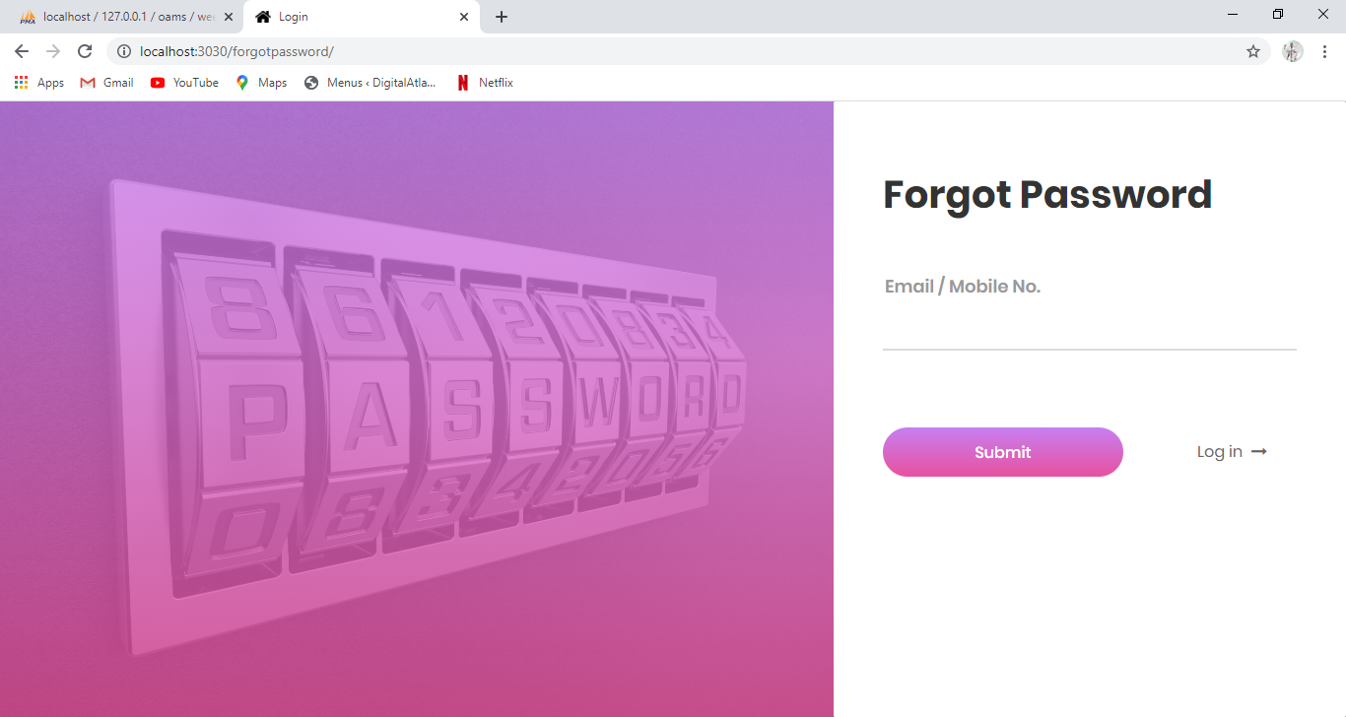

**Email for forgot password**

Consultant will receive an email and will be provided a temporary password which he can change later or he can generate a new password using the link given.

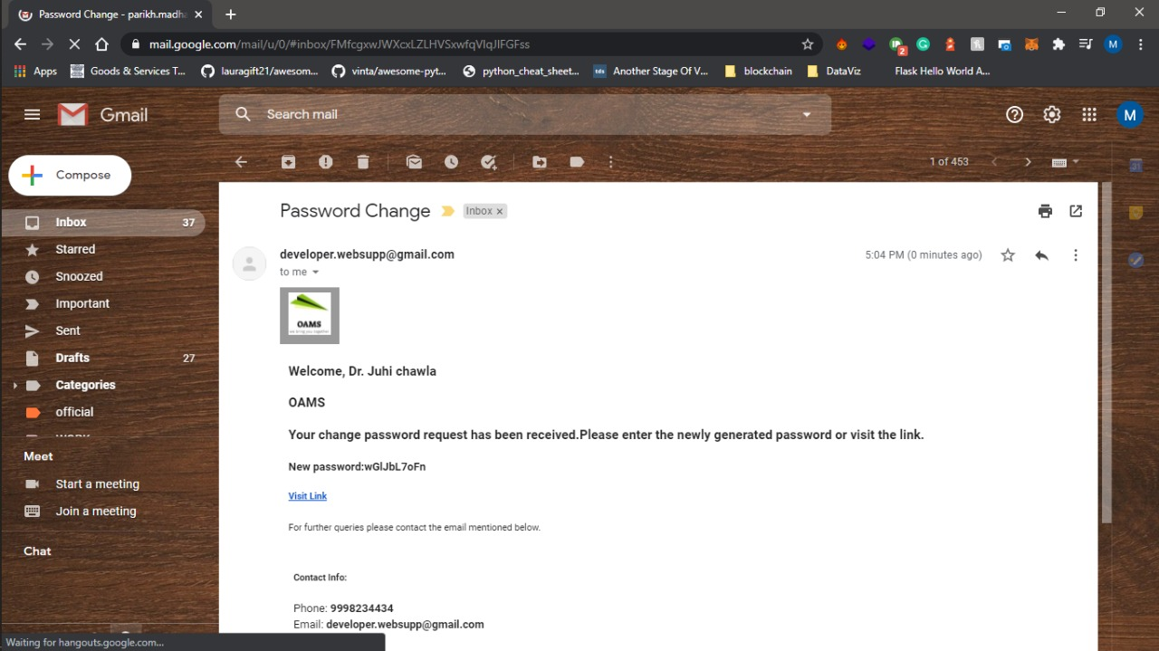

On clicking the link consultant will be redirected to the forgot password page where he can enter his new password and confirm it.

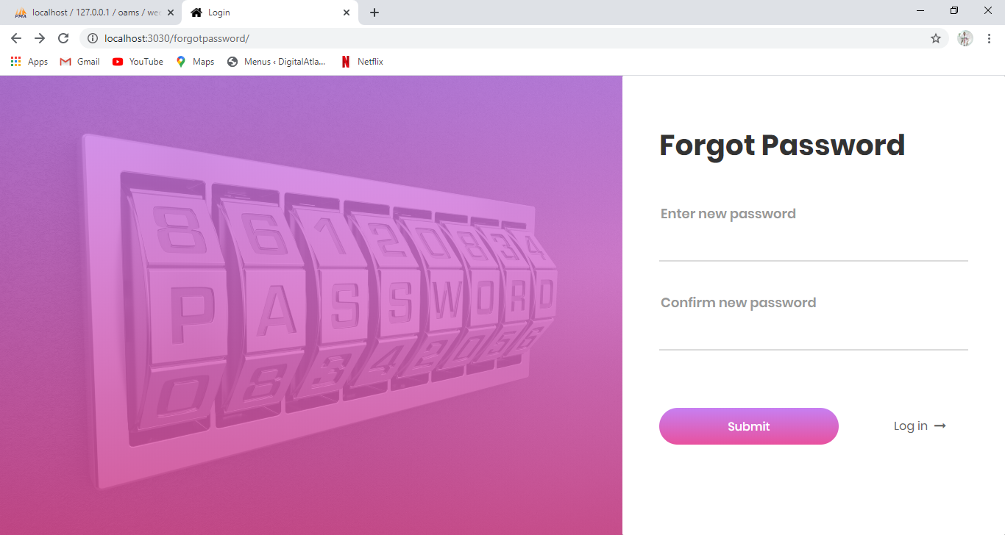

**CONSULTANT DASHBOARD**

Update Password form is used to set or update password. By entering password and clicking update password button, password will be updated.

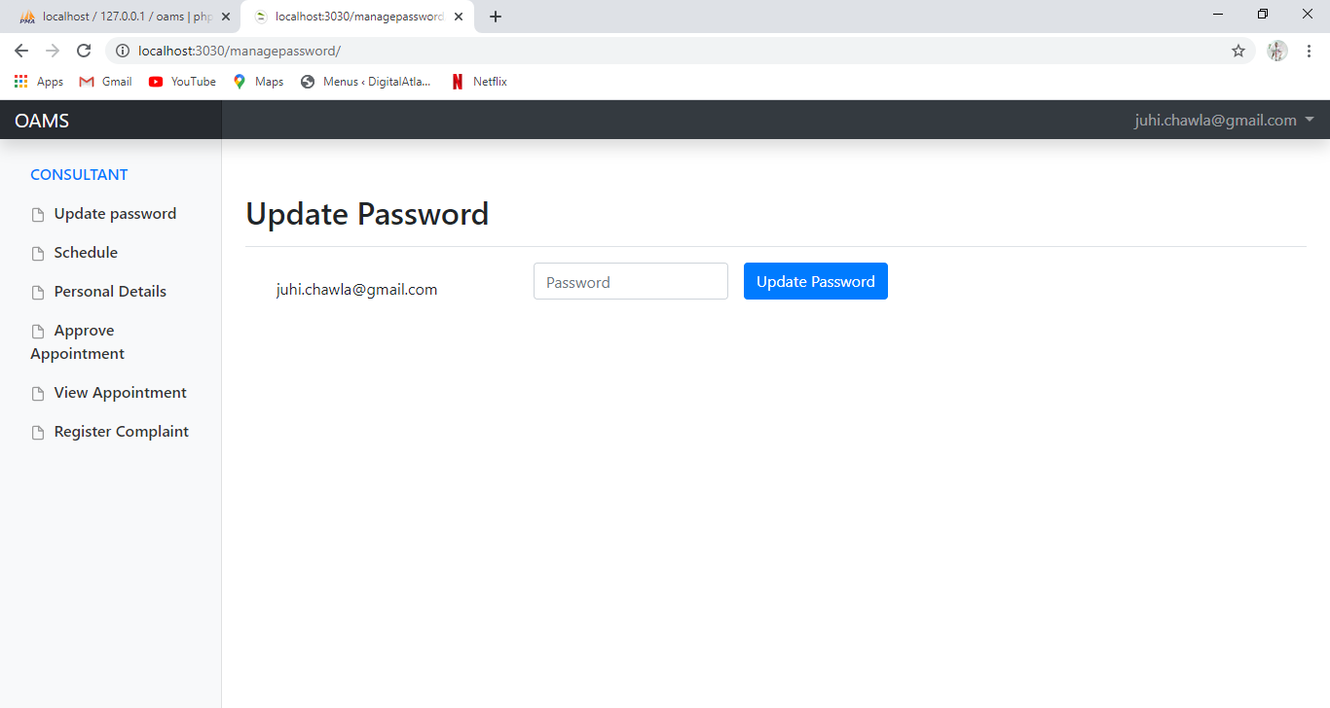

**Schedule (consultant can update his schedule)**

Schedule form is used to update schedule details by consultant which includes date, time and limit for the number of appointments to be booked as per his convenience. User will be able to book an appointment on the basis of schedule details provided by the consultant.

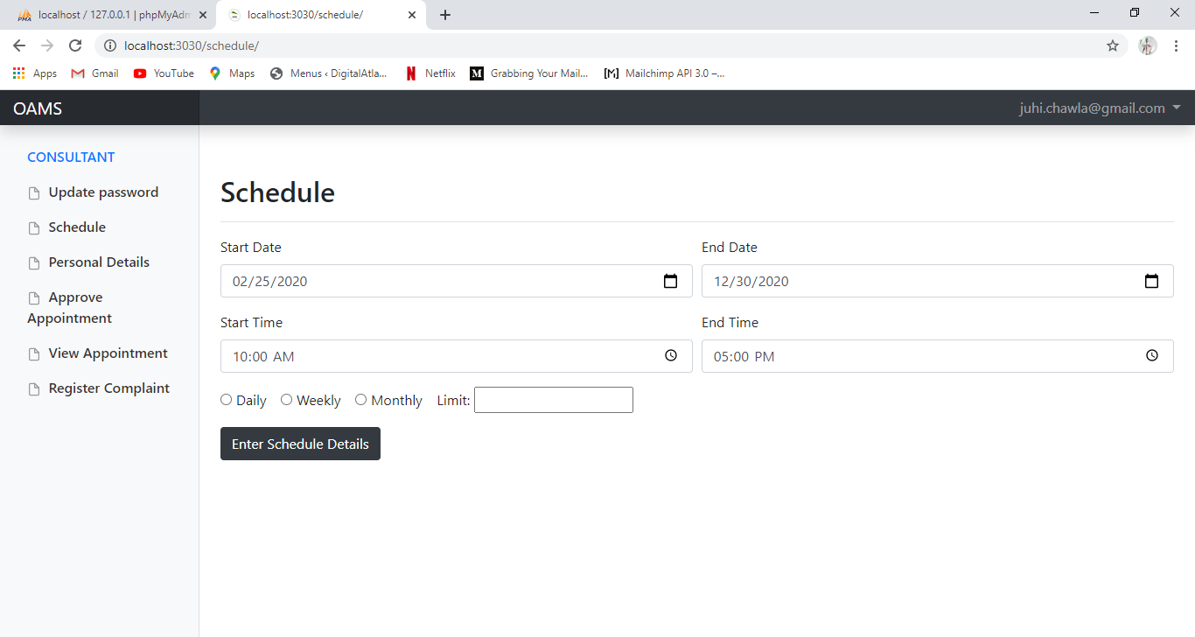

Start date and end date will provide the range of dates in which consultant will be able to consult his respective clients. For the selection of date, calendar control is provided

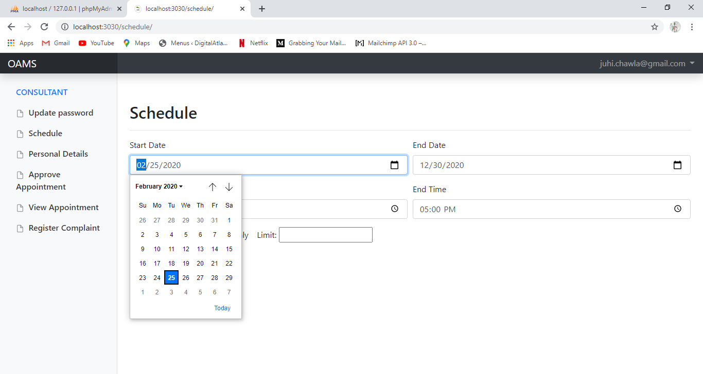

start time and end time will select the duration of consulting time from the beginning till the end of the day.

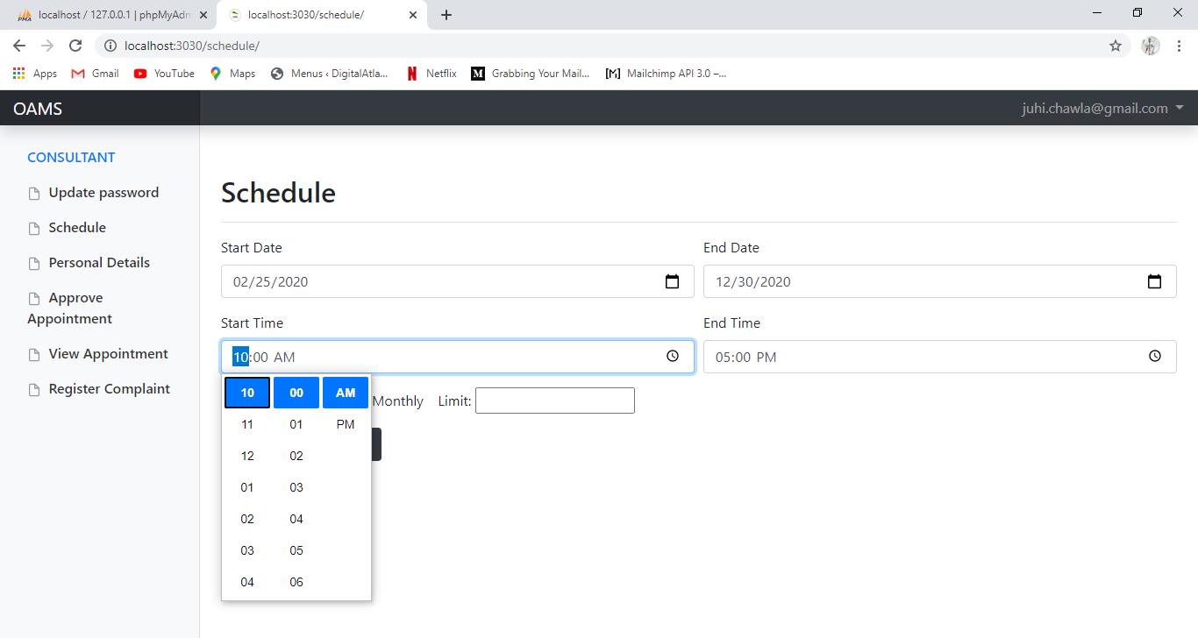

Consultant is also able to set his schedule on the basis of daily, weekly and monthly.

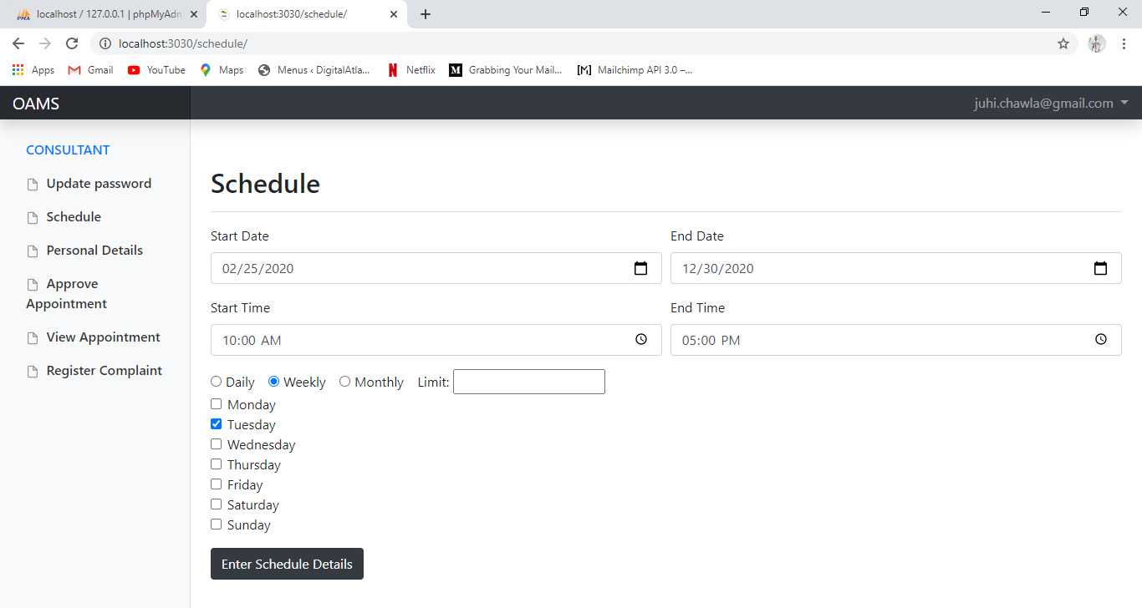

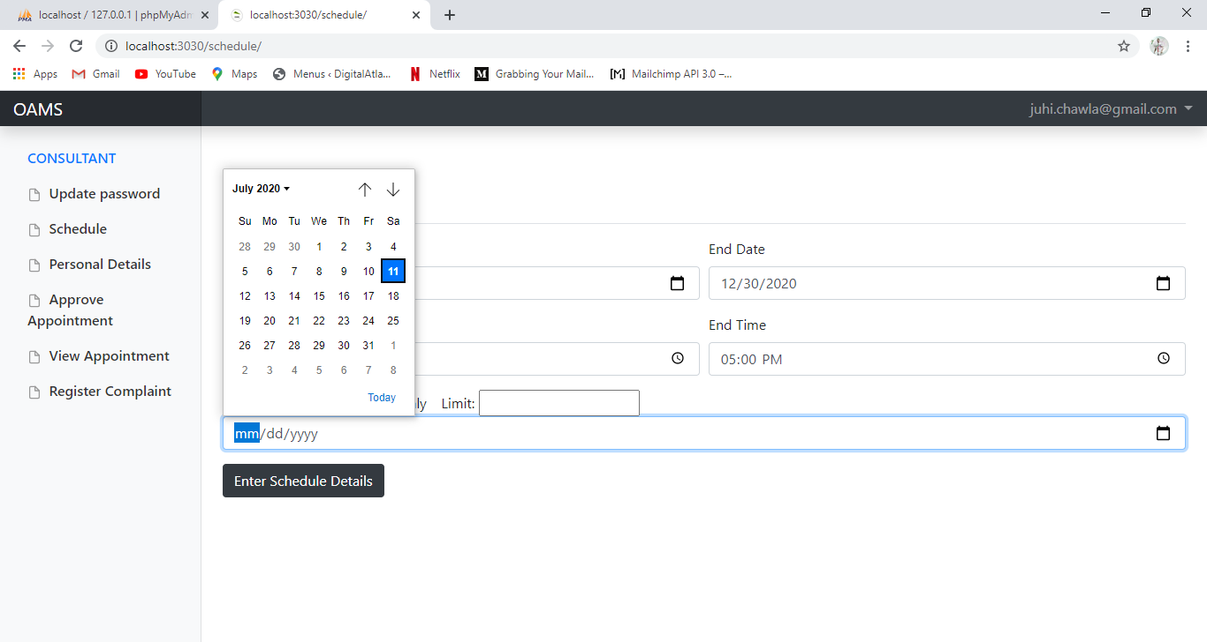

Consultant can set the limit or the number of clients he will be consulting within the schedule set by him.

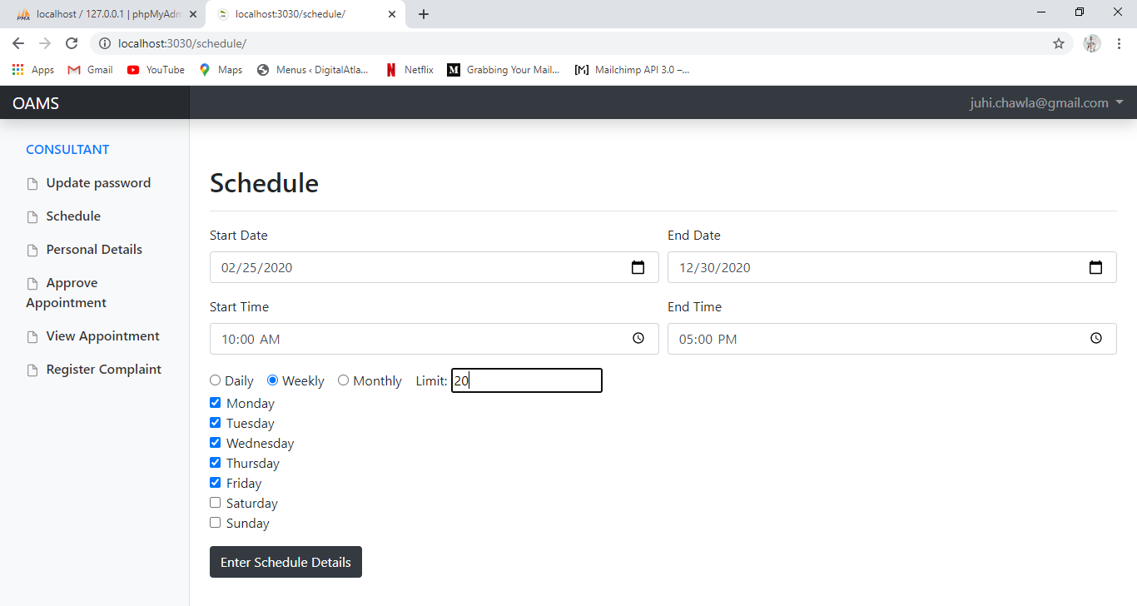

**Personal details (consultant can update his personal details)**

Personal Details form is used to update basic as well as educational details of consultant as per the requirement.

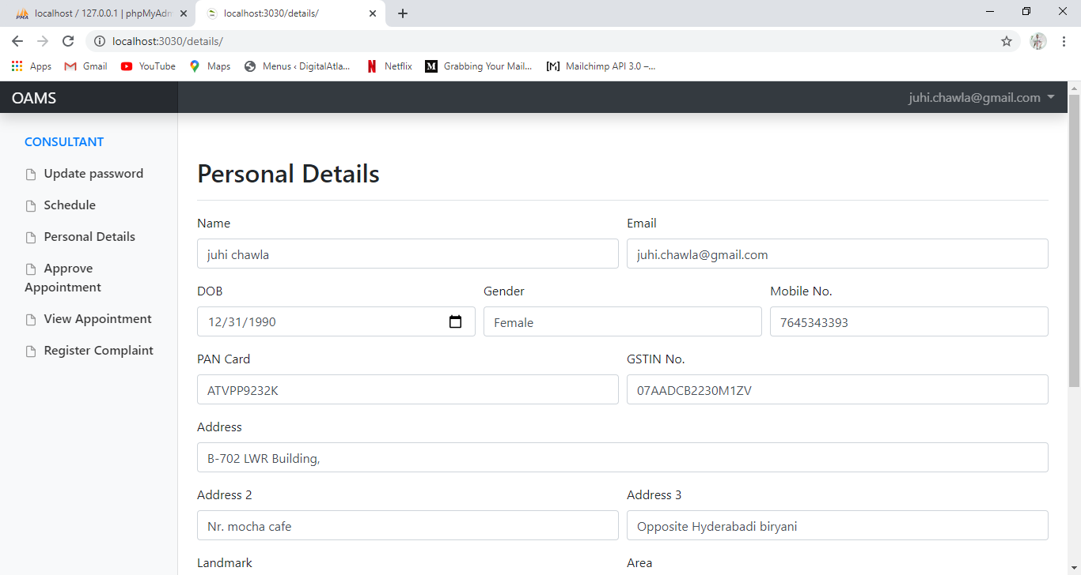

By clicking on the update details button the details of the consultant will be updated.

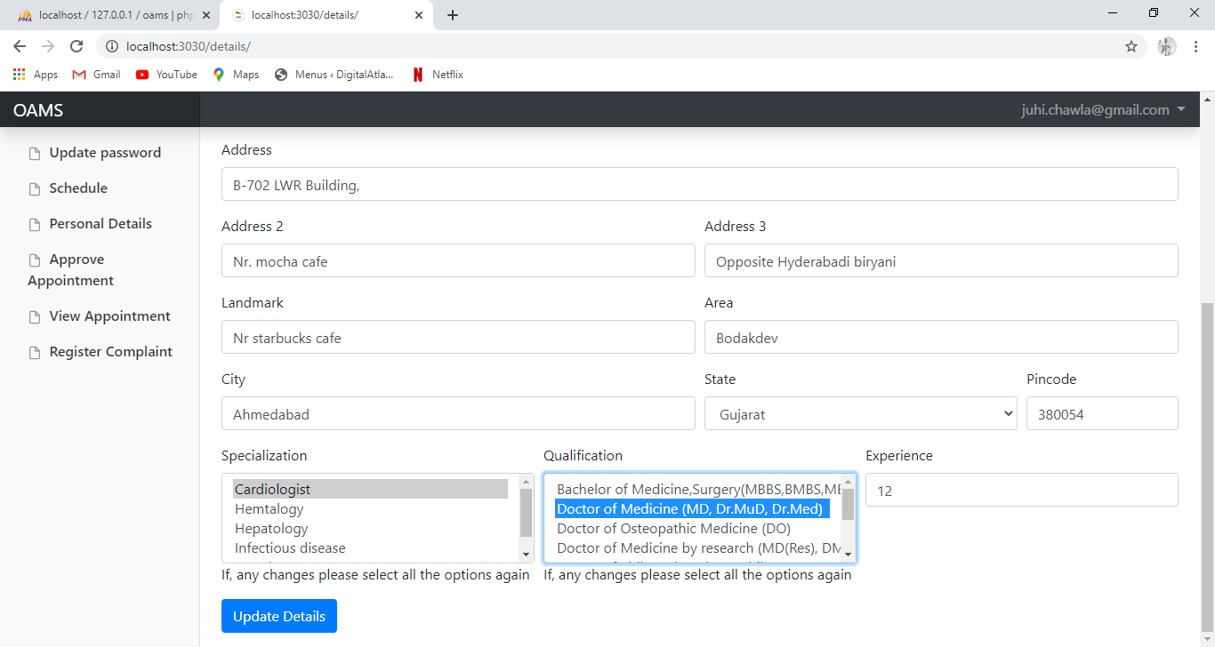

**Approve appointment (consultant can approve the appointments booked for him)**

Approve Appointment form is used for the confirmation of appointment booked by the user. Consultant can accept or reject the appointments using the accept and reject buttons. If the number of Appointments are more then multiple selection is provided. From the approve column, consultant is able to select the appointment and then accept or reject using the buttons accordingly.

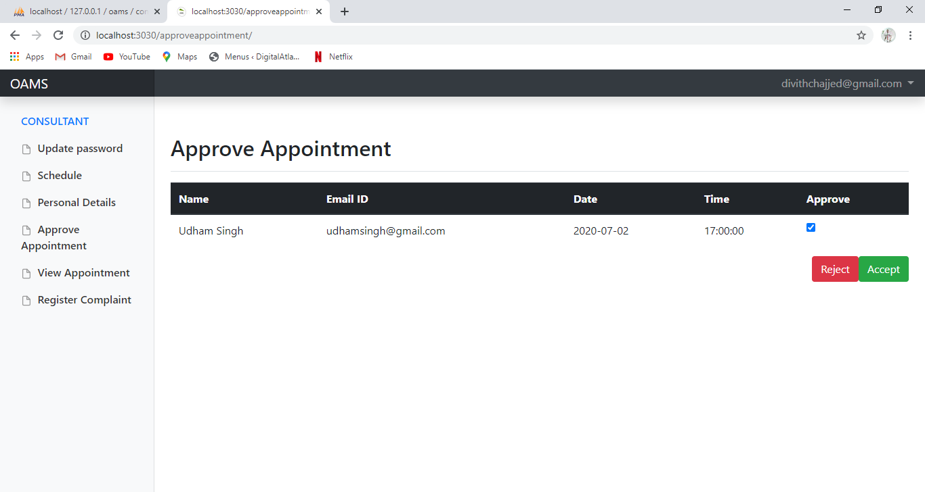

**View appointment ( consultant can view the approve appointments)**

View Appointment form contains the booking information of user which includes name and email id of user , date and time scheduled for the appointment

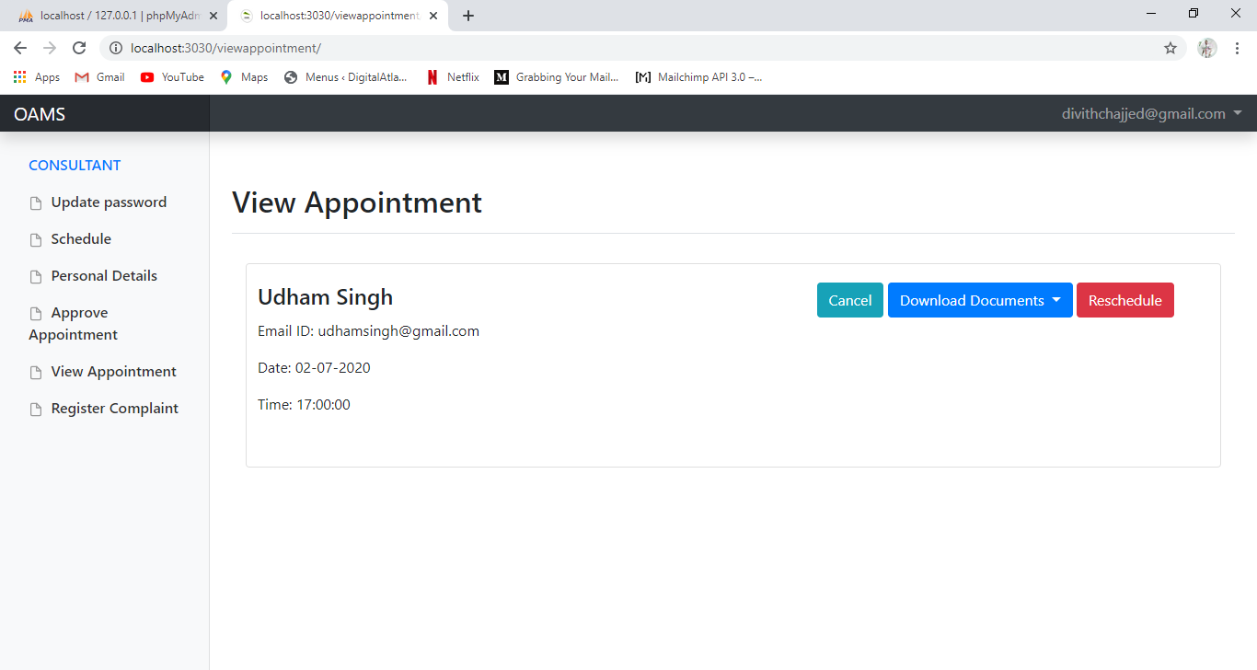

consultant can download the required documents uploaded by the user

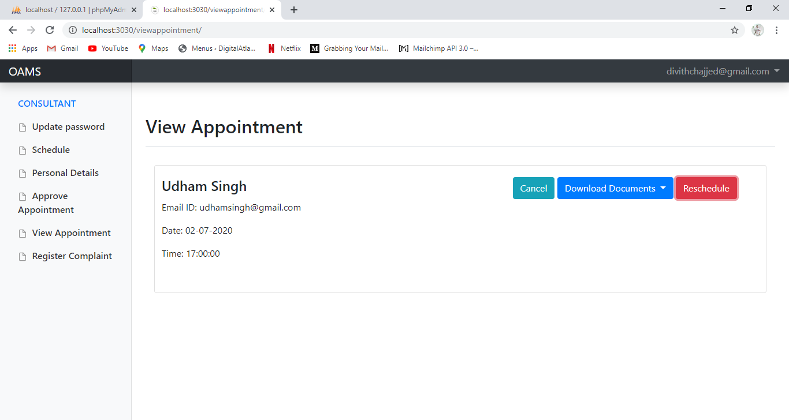

If the user have uploaded his reports than the consultant will get a message written in the appointment section and the download documents color will be changed to green.

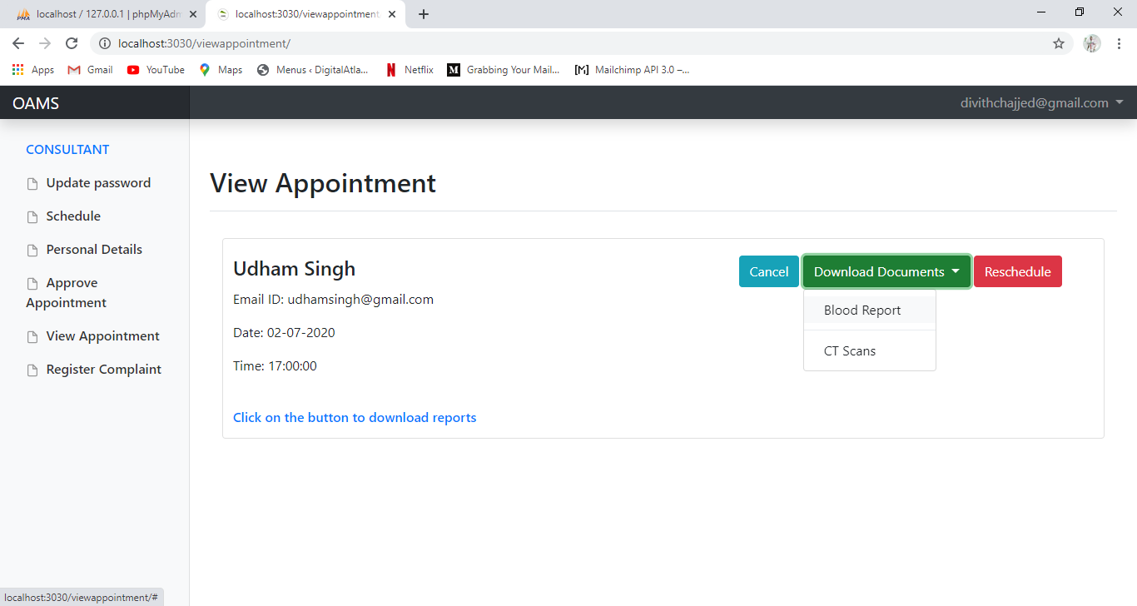

consultant can also reschedule or cancel the appointment.He can select the rescheduled time and date and after clicking on the approve button the appopintment will be reschedule and user will receive the mail.

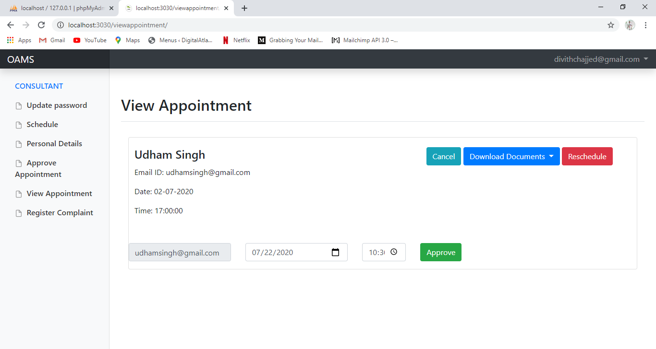

**Register complaint (consultant can register complaint against user)**

Register Complaint form helps consultant to express his displeasure by registering complaint against the respective user.

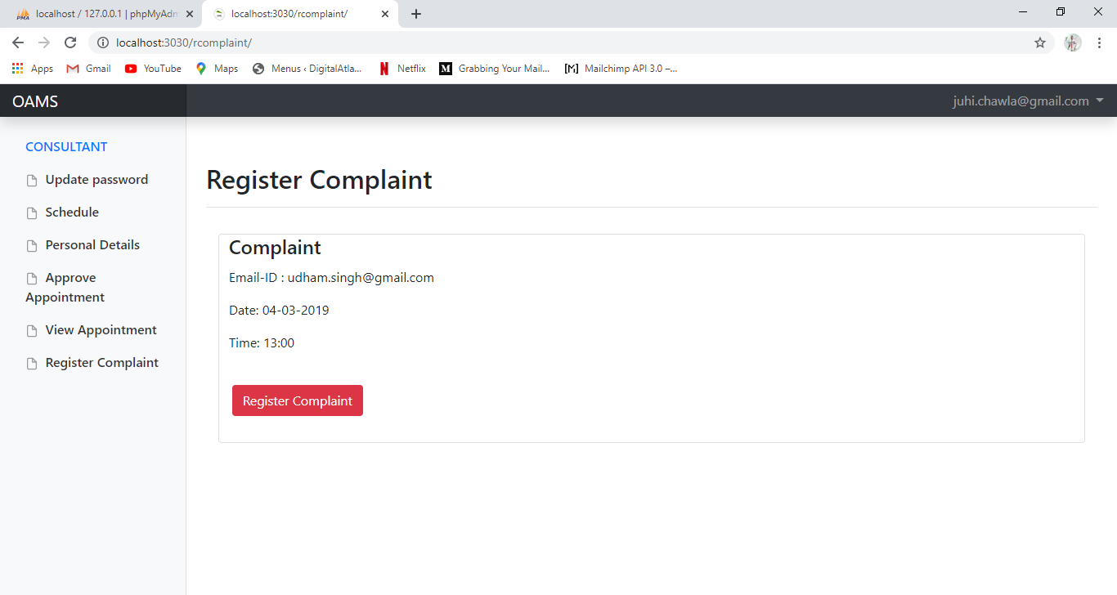

By selecting register complaint button, a modal box will pop up which will ask consultant to submit the email id of user, issue and description for the complaint to be registered.

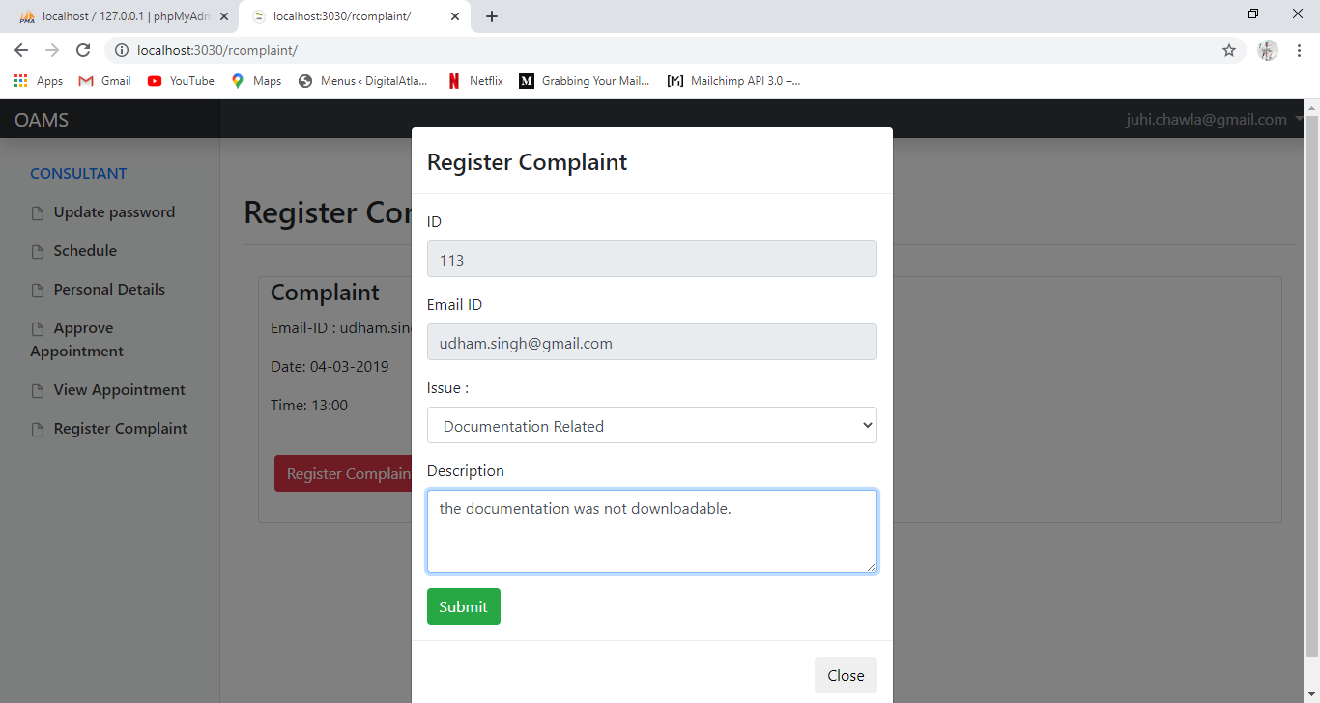

**Email received after complaint registration**

After registering the complaint, consultant will receive an email notifying that complaint has been registered.

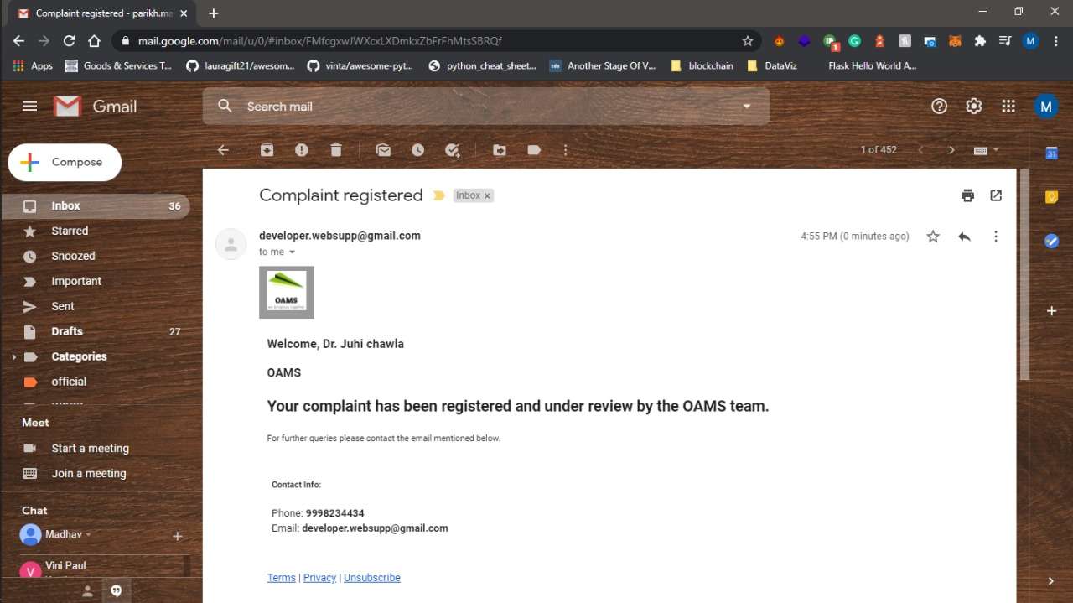

**Email received by the consultant for too many complaints on him**

Email received by the consultant when the complaint crossed a set limit

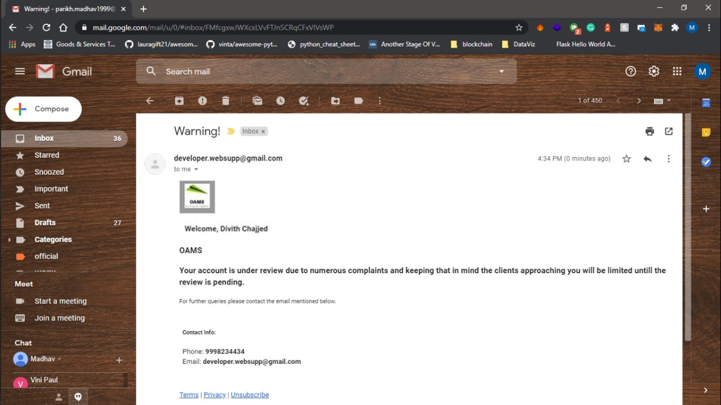

**Email received for action taken on the consultant against the complaints on him**

This is the email received by the consultant when the Admin deactivate his account from verify consultant Admin panel on the basis of the complaints registered on him.

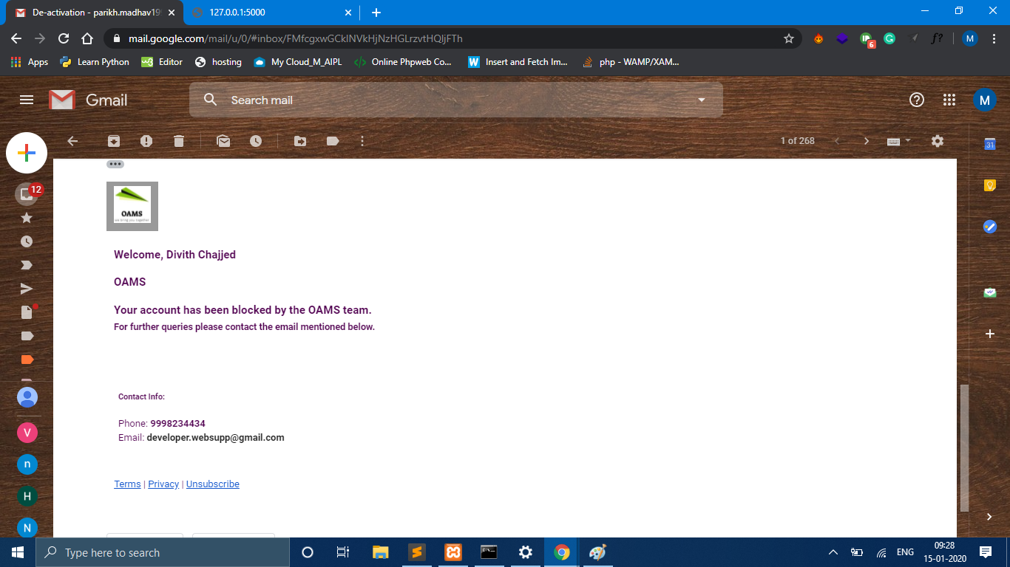

**USER SIDE**

**USER REGISTRATION**

The registration form is used to register the user on his basic details.Name cannot be left empty and it should not contain any digits.

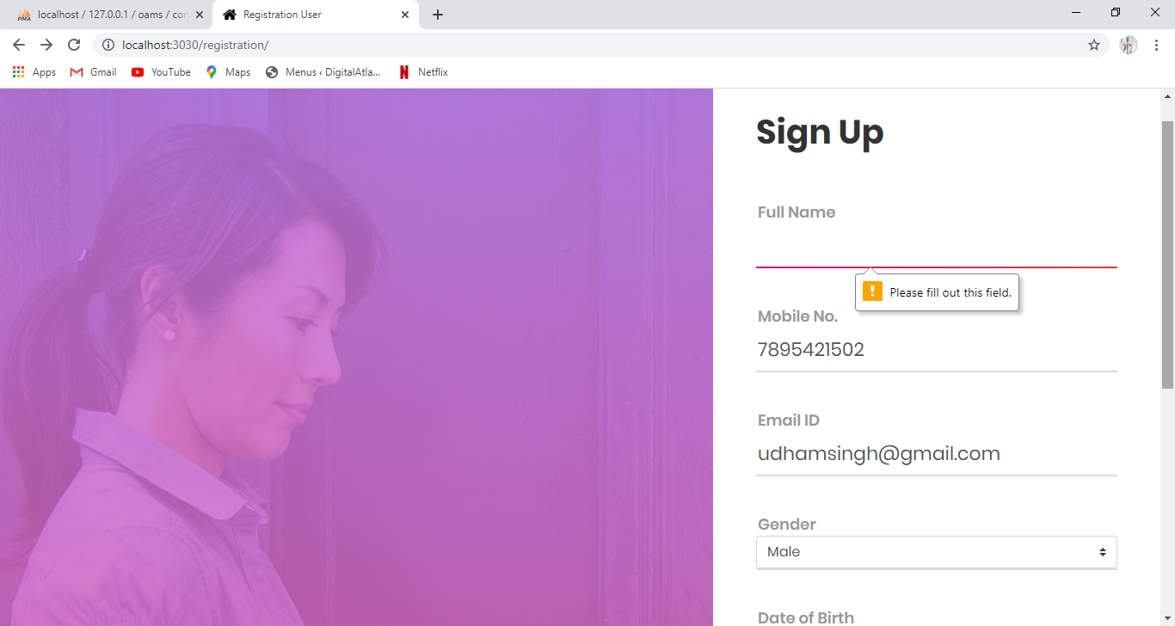

The name field should match the specified format it should only have characters.

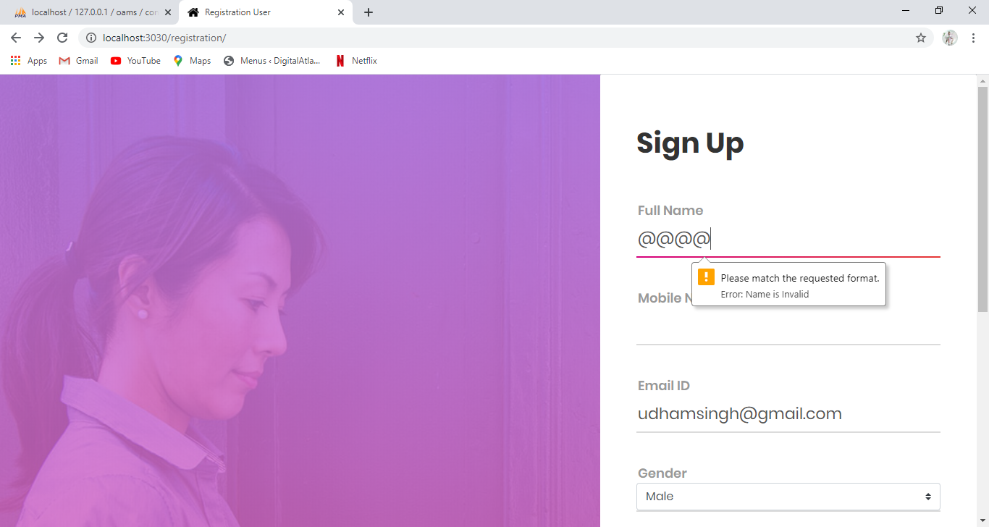

Mobile no. should match the requested format , it must be in digits.

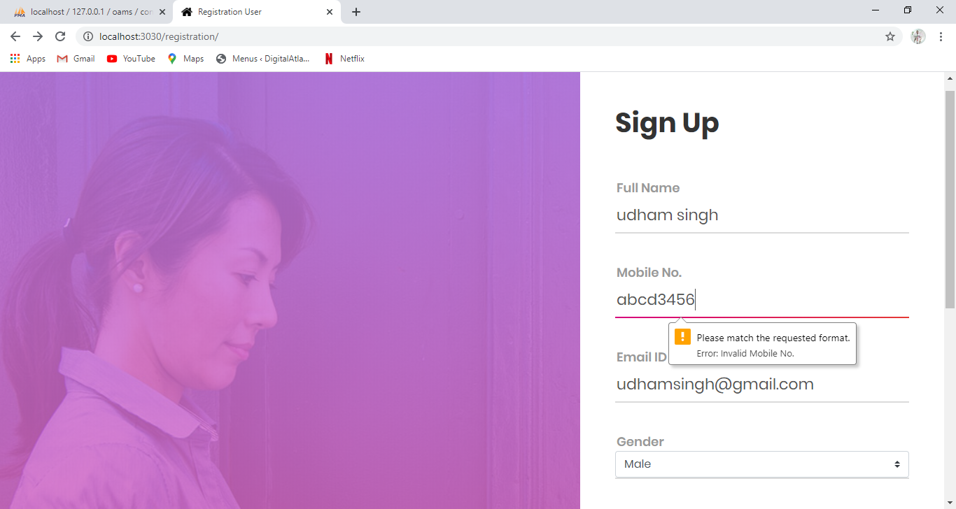

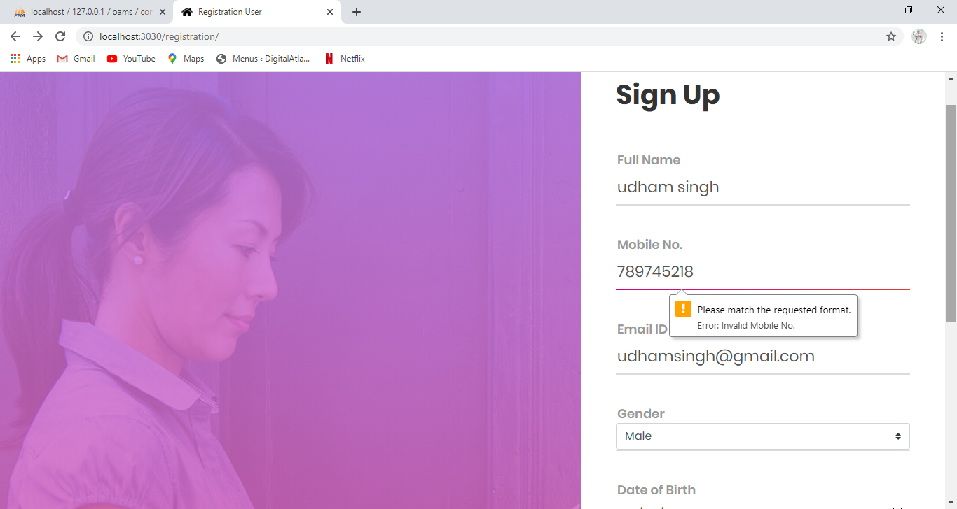

Email id should match the requested format which contains @ and (.).

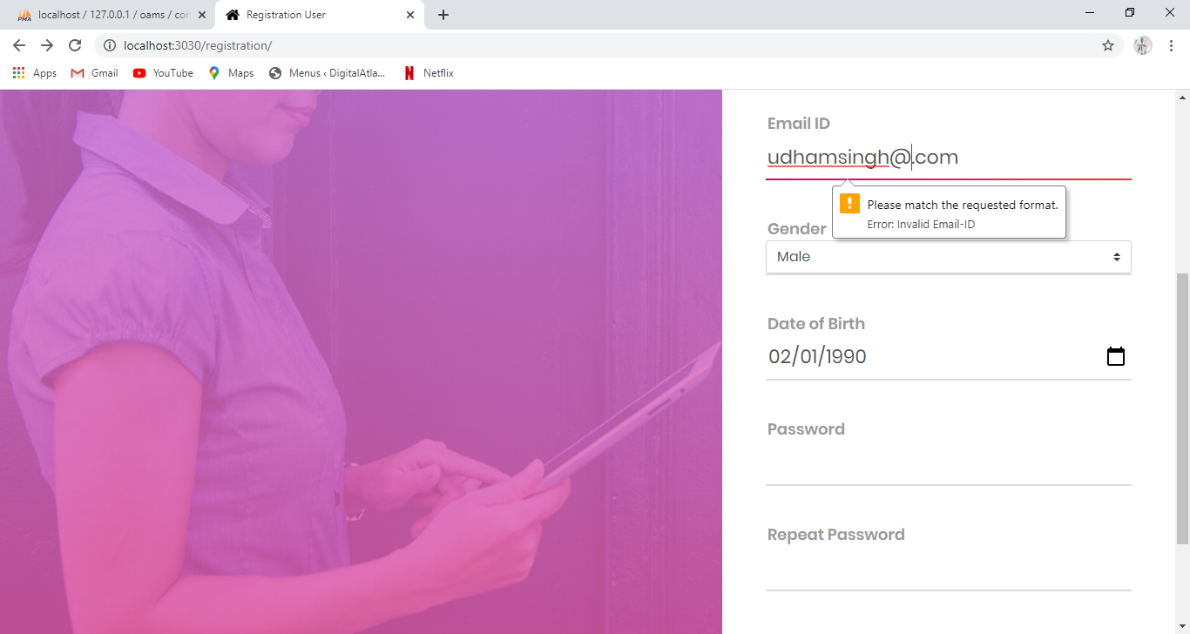

Date of Birth should not be empty and should be in a proper format and it should be more than or equals to 18.

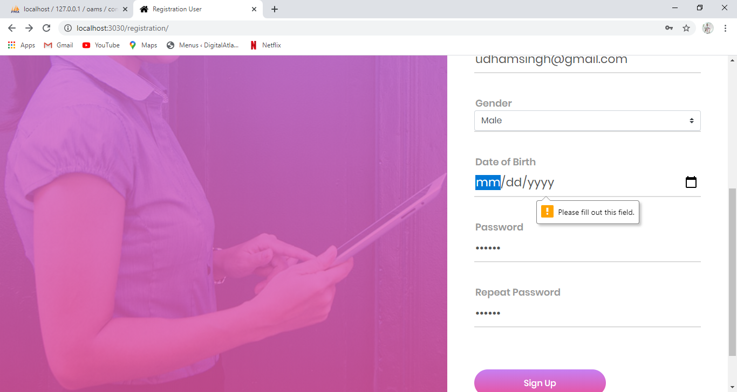

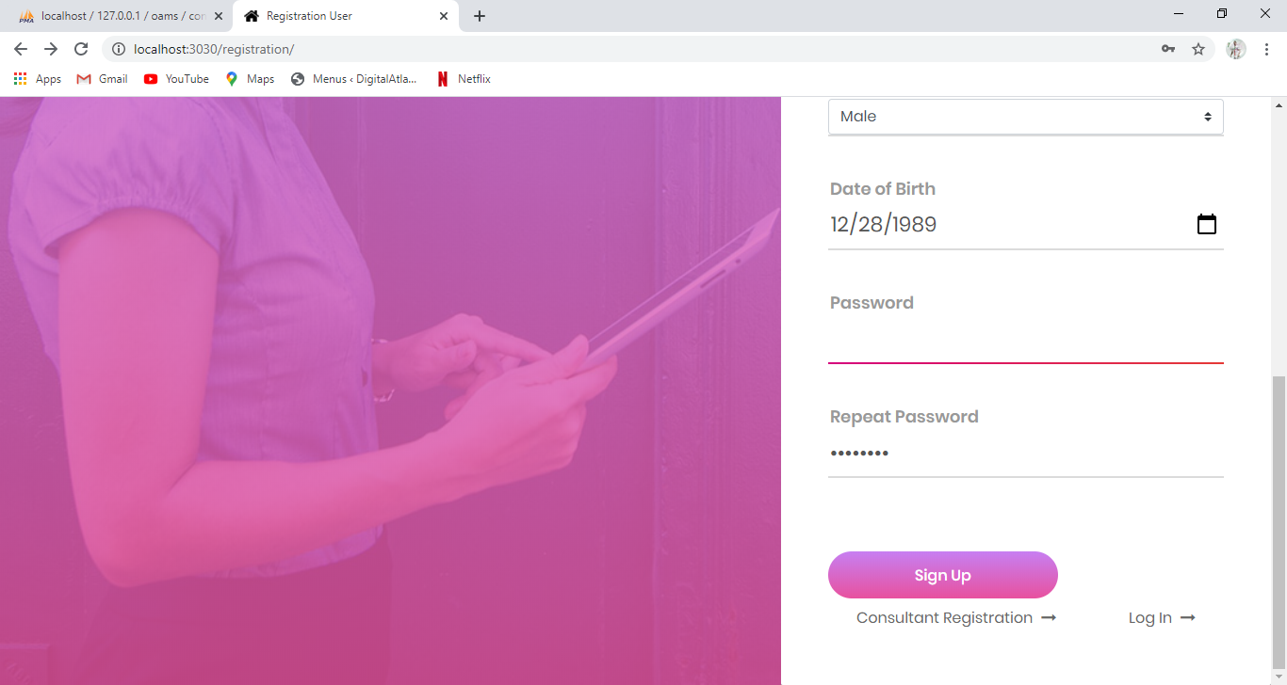

At the end password is entered and the same text should be entered in confirm password.

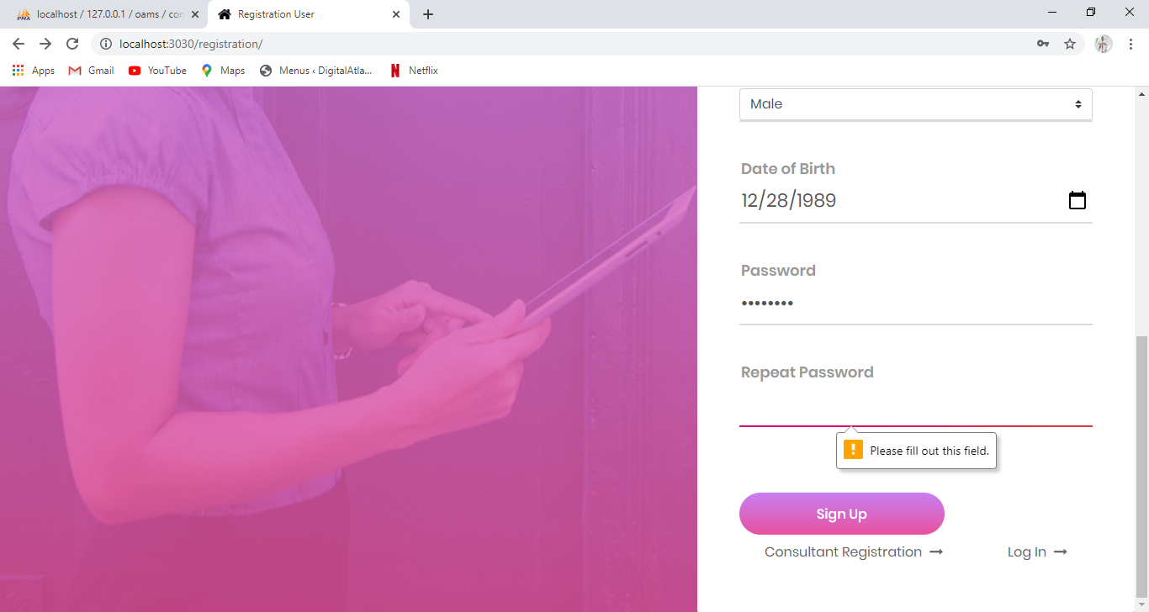

**Email for user account verification**

After clicking of the sing up button the user will receive a mail on his email id for the account verification.

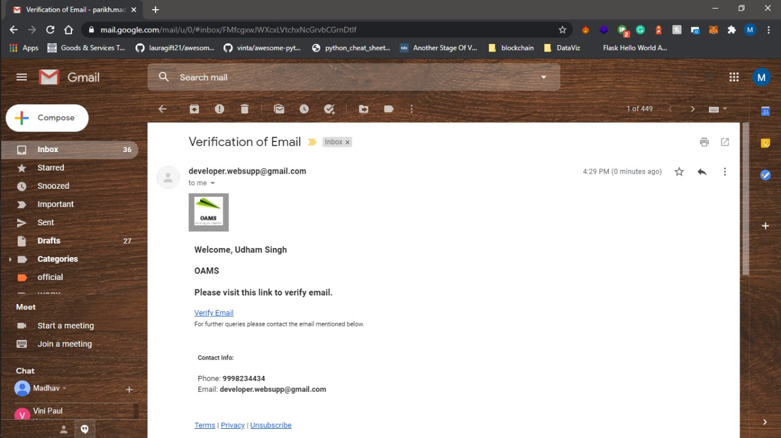

**USER LOGIN**

User login form helps consultant to login using email id/mobile no. and password which has been entered during registration process.

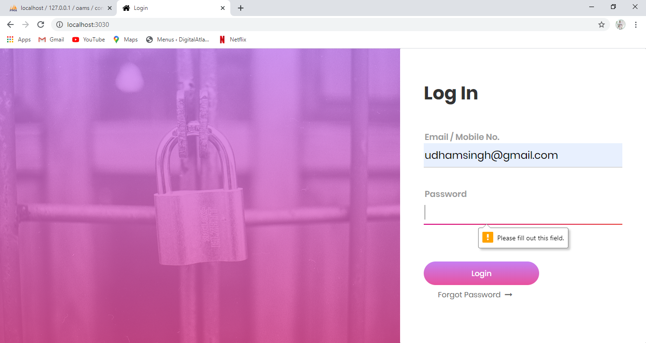

Email Address or mobile no field should not be empty.

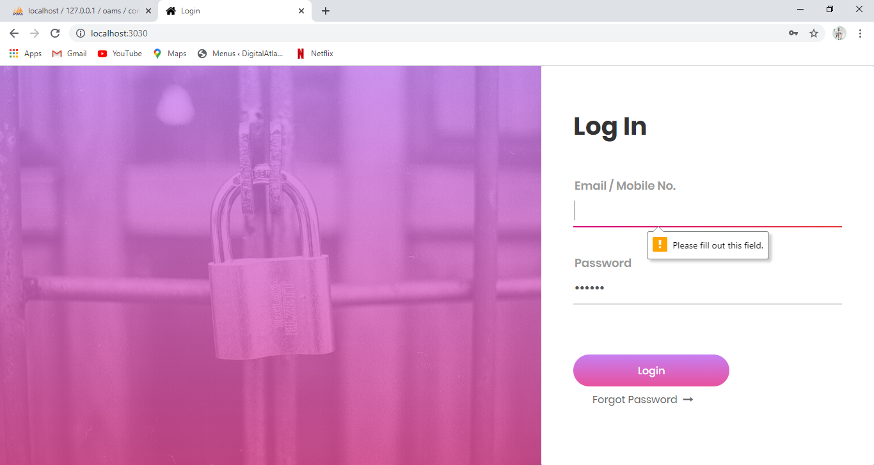

Email id should match the requested format which contains @ and (.).Mobile no. should match the requested format , it must be in digits.

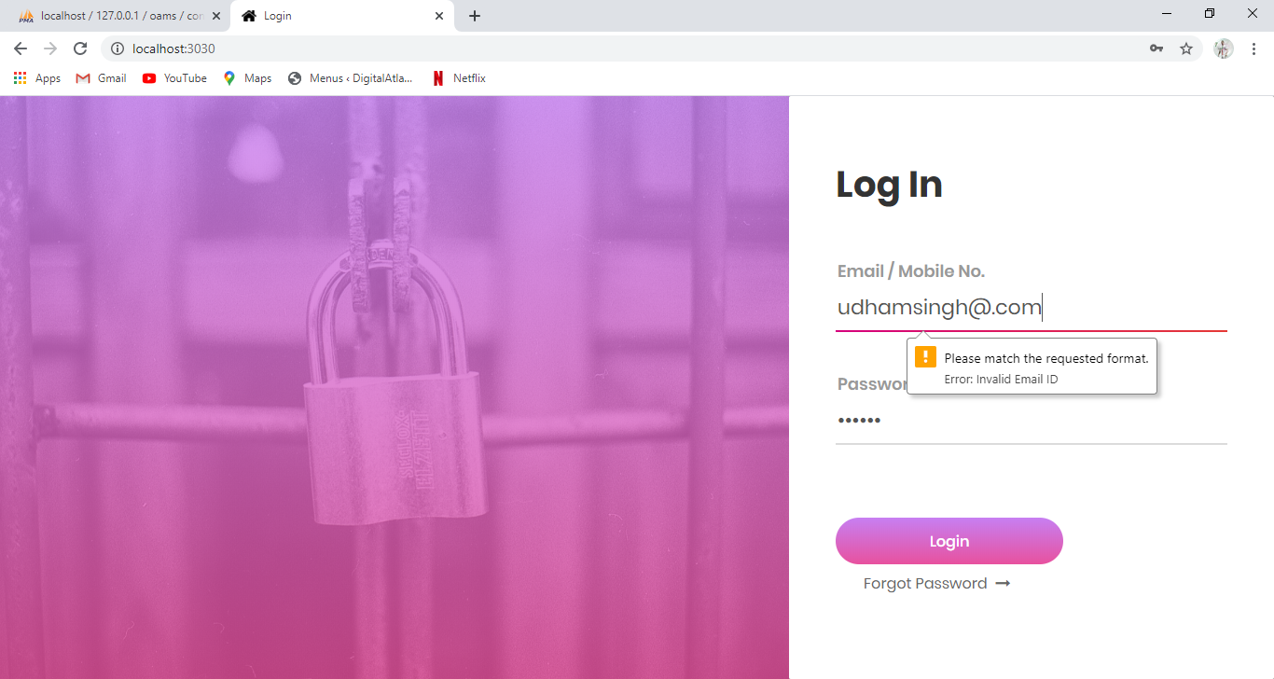

These details should match the details entered in registration form or else user won't be able to login.

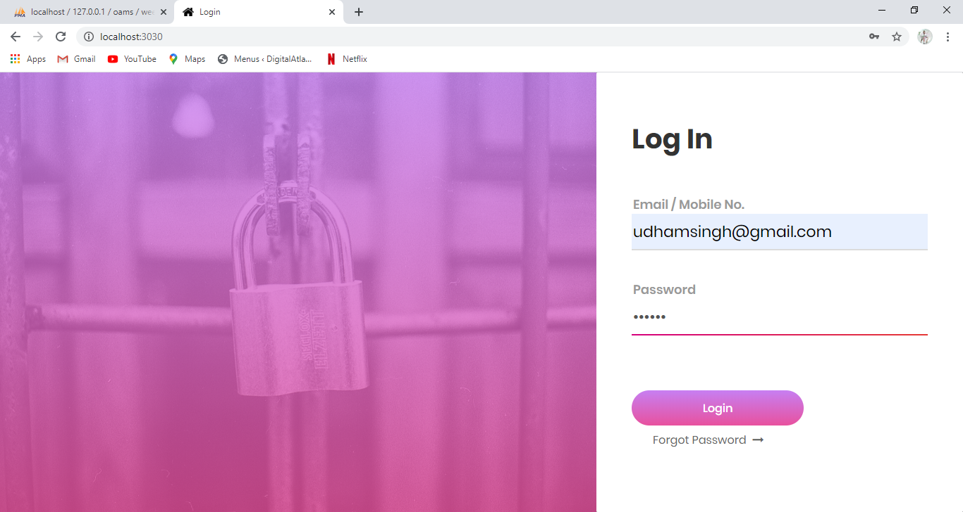

If the user is unable to remember his password, he can click forgot password button and further submit email id.

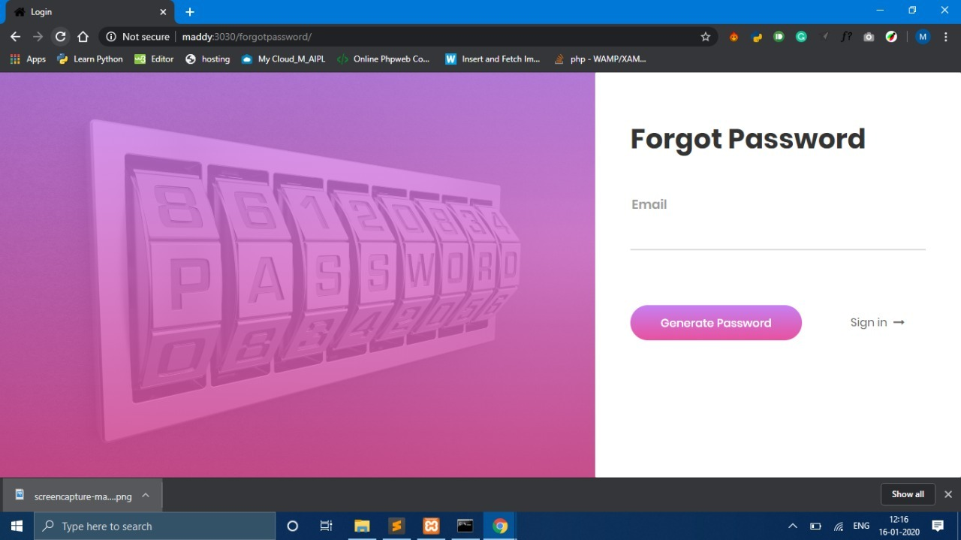

**Email received for forgot password**

He will receive an email provided with a temporary password or will be asked to generate a new password by clicking the link.

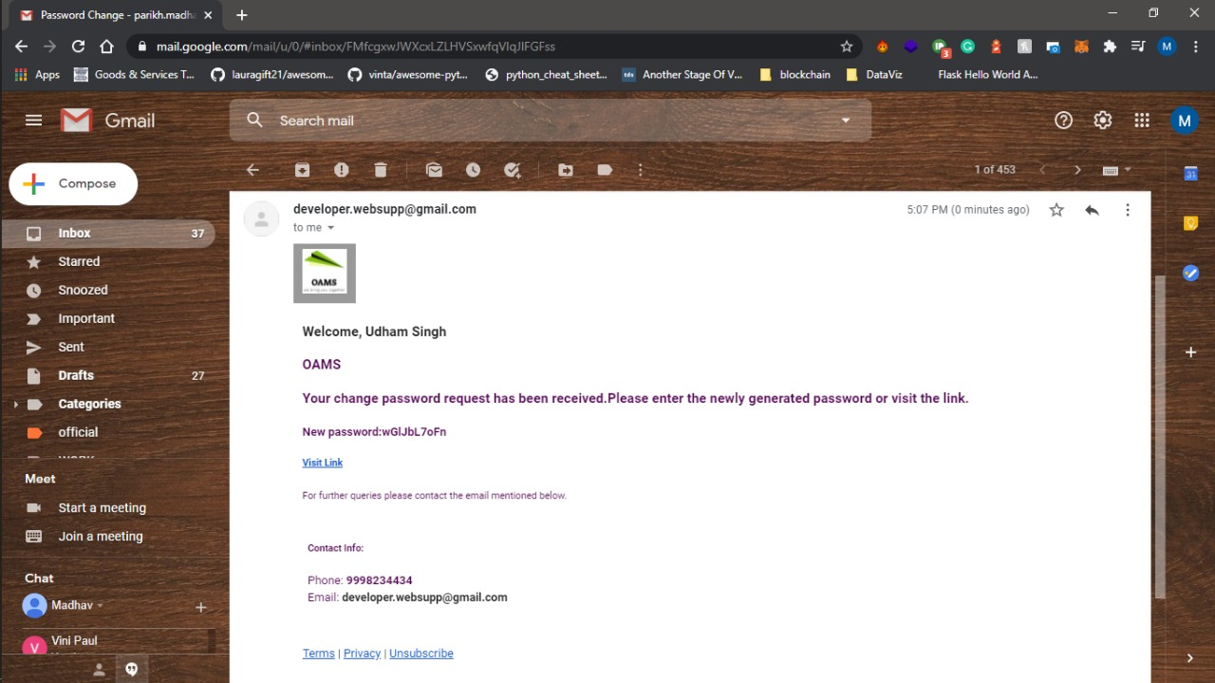

After clicking the link he will be redirected to the forgot password page where he can enter his new password.Using his new password, he will be able to complete his login process



**USER DASHBOARD**

**Personal details**

Personal details form is used to update or change the personal information of the user.

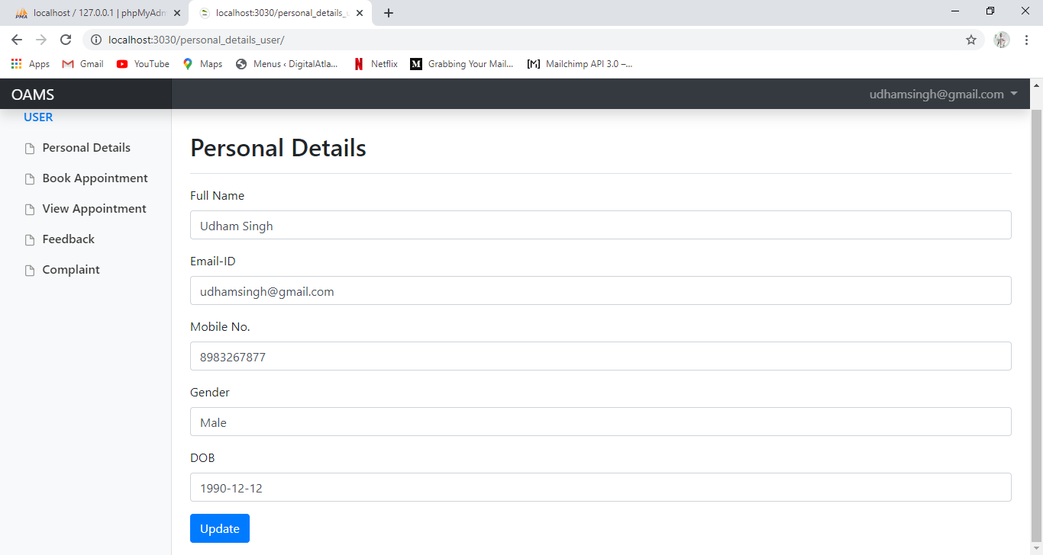

**Book appointment(user can book the appointment)**

Book appointment form is used to select respective professions, view their details in brief and book the appointment by the user as per there own convenience of date and time which will be checked or validated against consultants preferences.

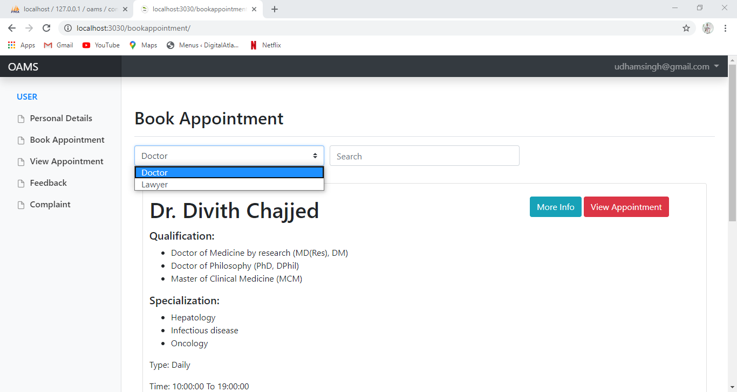

More info button It will display the the information regarding consultant like specialization and schedule

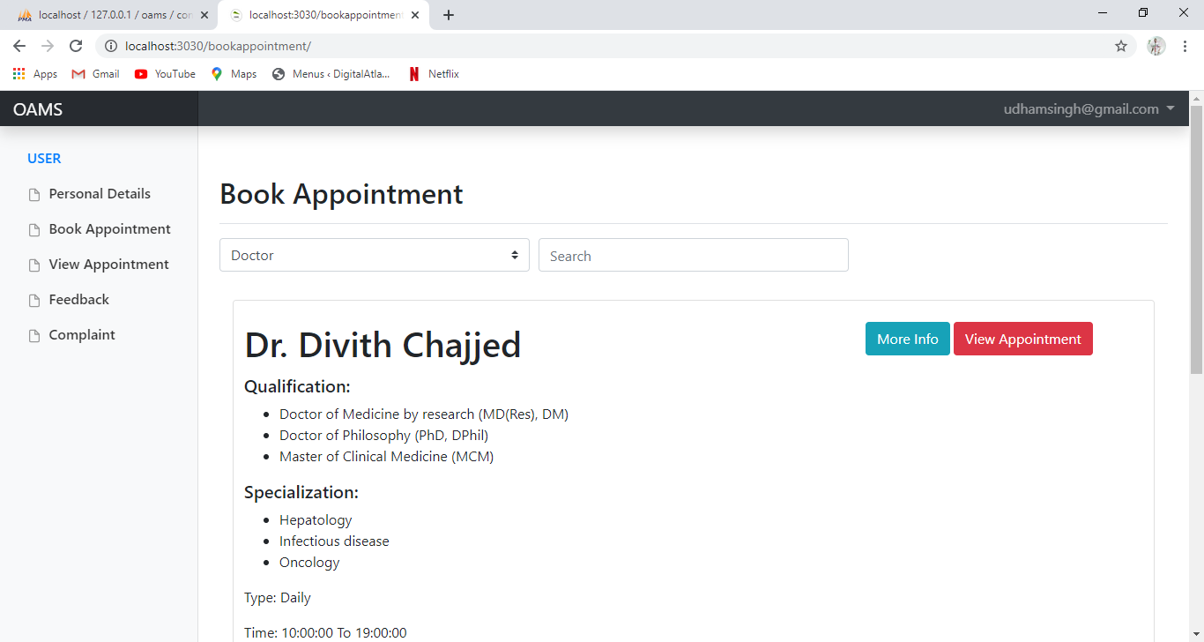

View Appointment button will display EmailID of the consultant,date to when the appointment is made as well as time

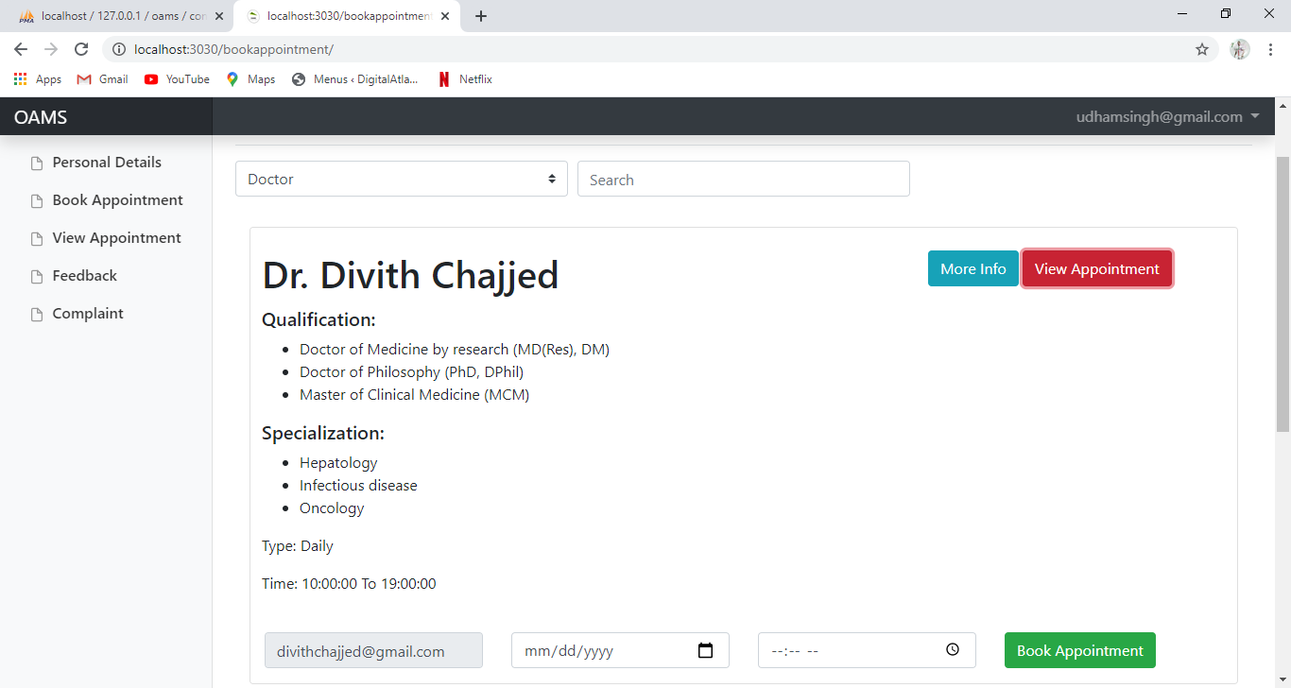

After filling the details book appointment button will send the prompt to consultant for approval of appointment.

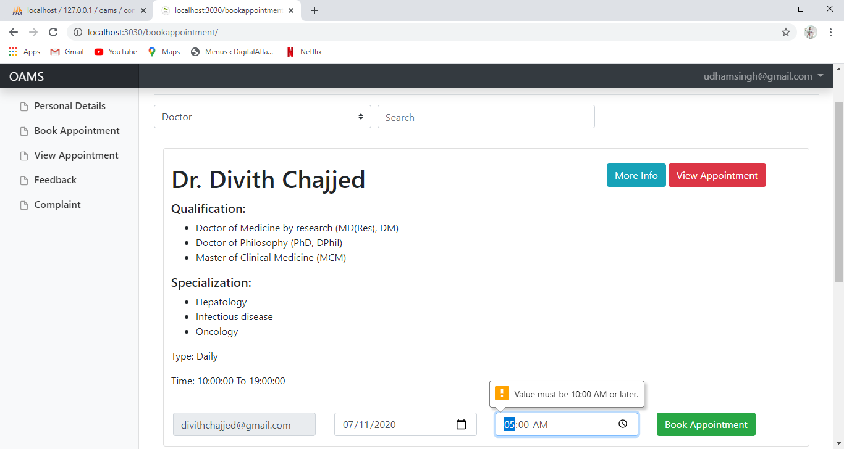

**View appointments(user can view the booked appointments)**

View Appointment displays the appointment approved by the respective consultant and shows the contact information as well as appointment information of the consultant. Cancel button is used to discard the appointment with the consultant. Register Feedback button is used register feedback for the respective consultant

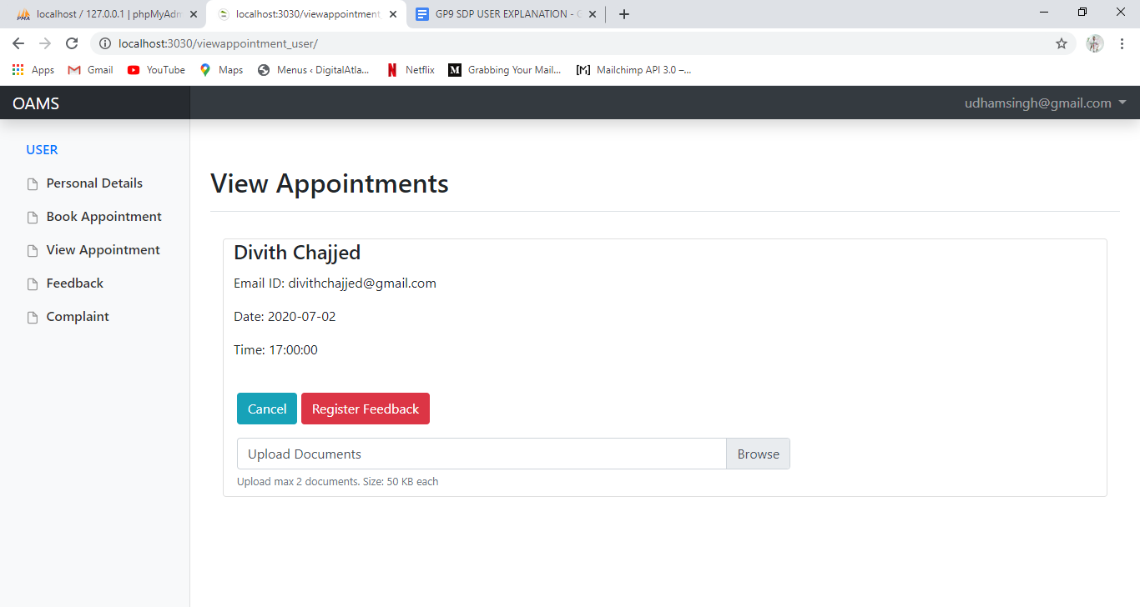

On clicking on the browse button user can upload his reports.The maximum number of reports that can be uploaded by the user are two.

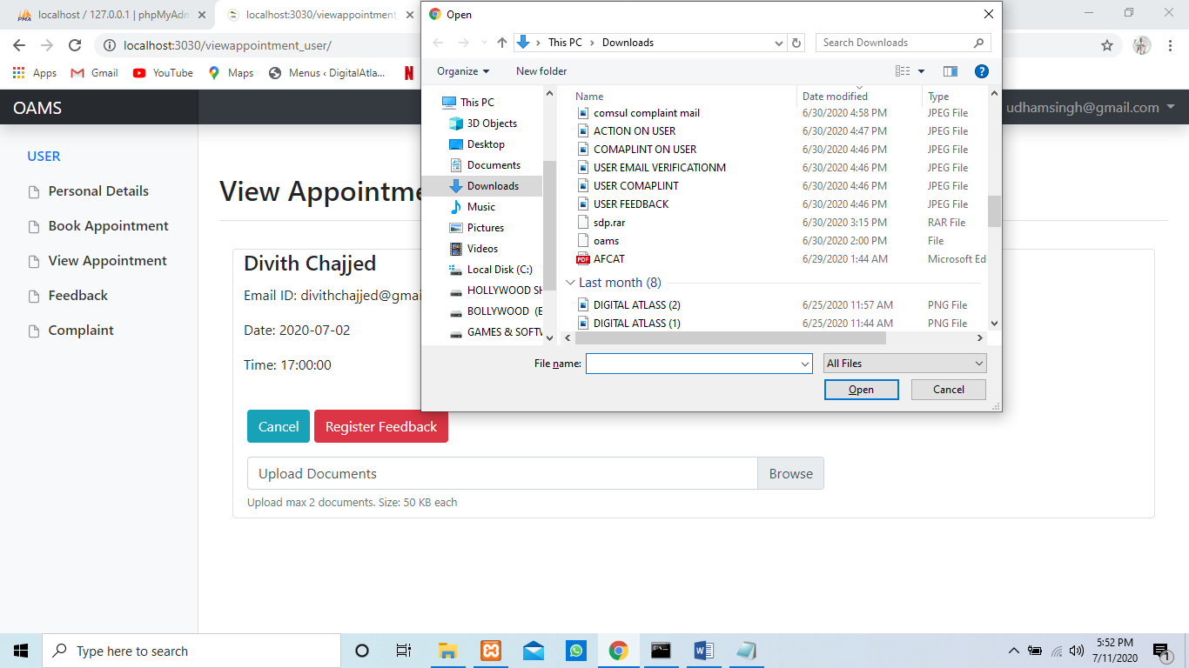

**SMS notification received by the user for the upcoming appointment**

SMS received by the user two hours prior to his appointment.

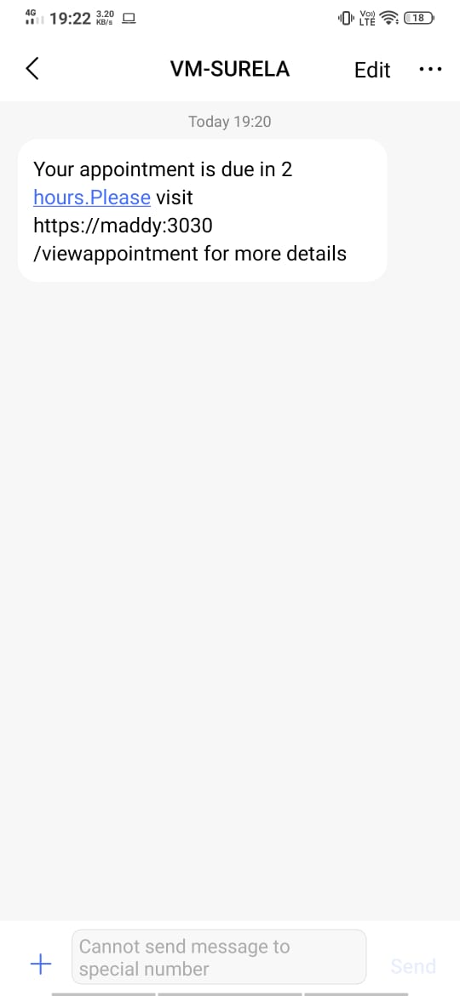

**Feedback ( user can give his feedback on the consultant)**

The user can register the feedback for the consultant on the basis of the appointment which have been completed.

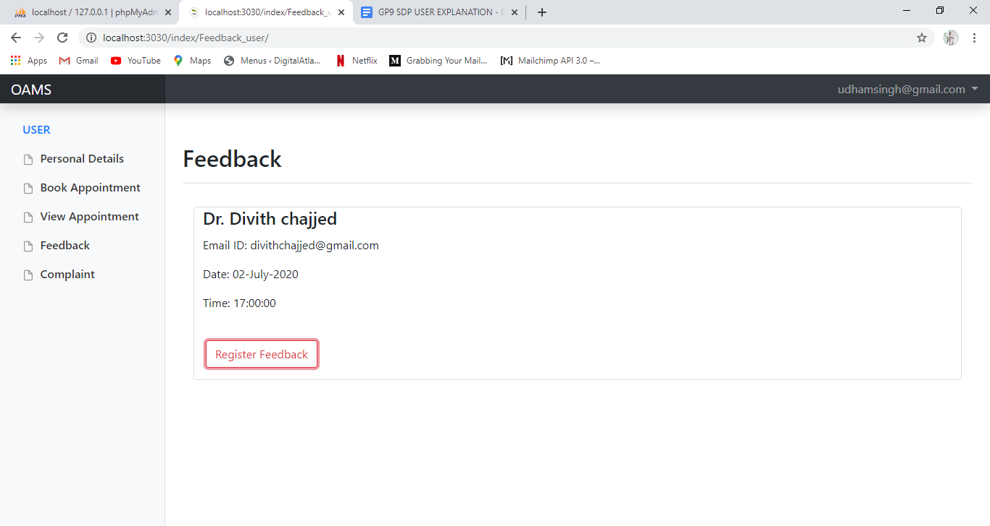

user can select the ratings as well as pass any comment on consultants whom they have an appointment with.

Ratings will be have a range from 0-5 and comments can be kept empty and can be as long as 255 characters.

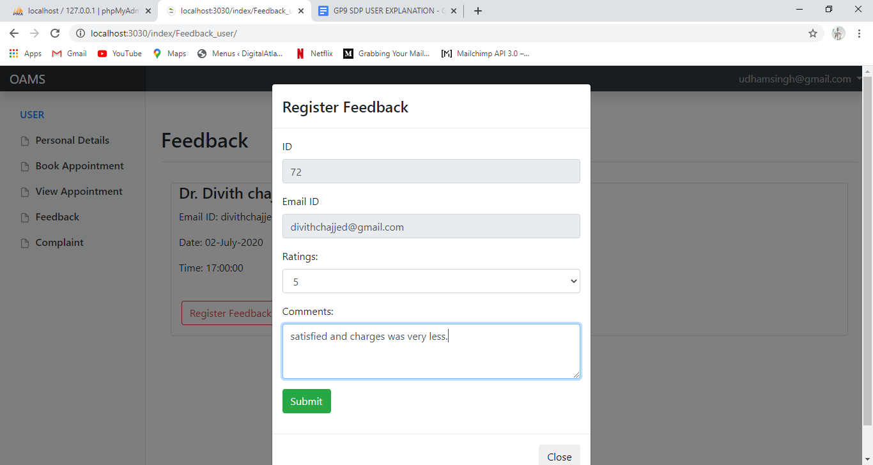

**Complaint(user can register a complaint on consultant)**

User can registered a complaint against the consultant whose appointment has been completed.

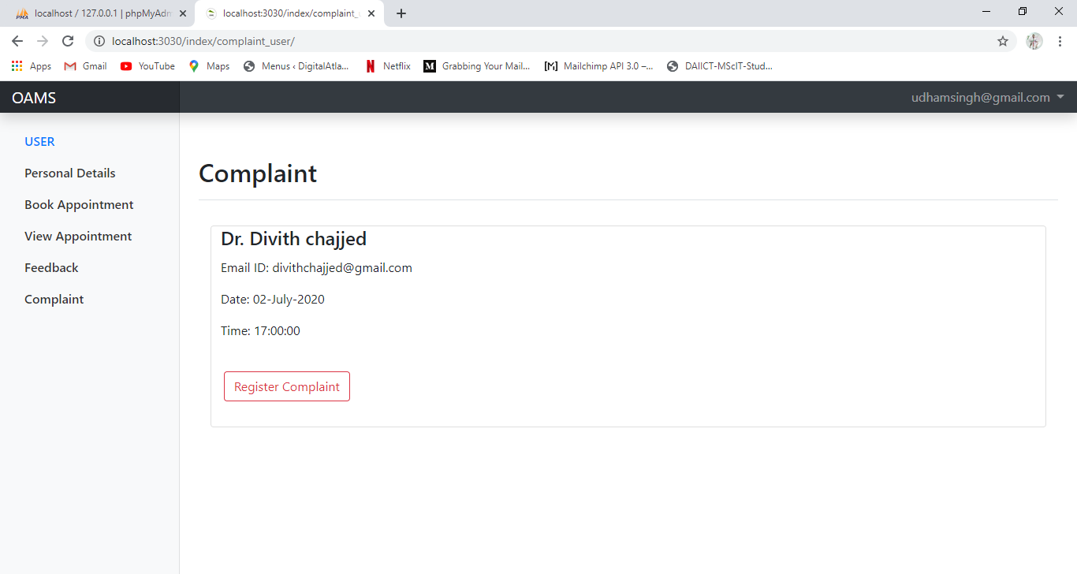

Users can express their displeasure by registering the complaint against the respective consultant by mentioning the issue as well as registering the written complaint

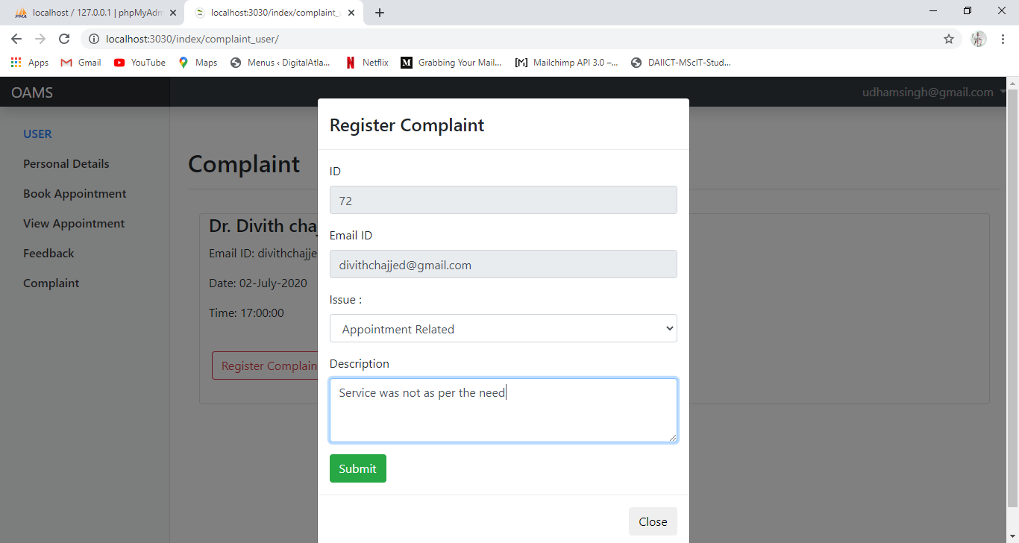

**Email received after registering a complaint by the user**

This is the email received by the user after successfully registering the complaints.

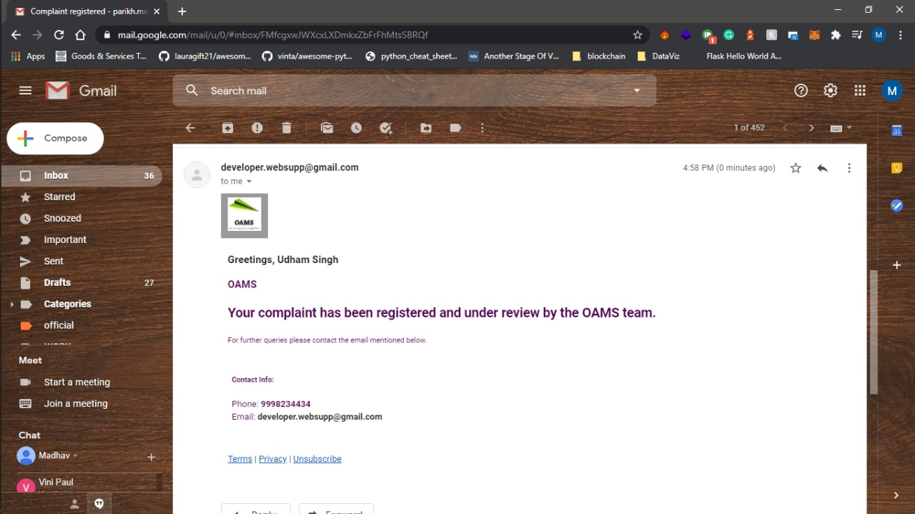

**Email received by the user for too many complaint on him**

This is the email received by the user when the complaints crossed a set limit.

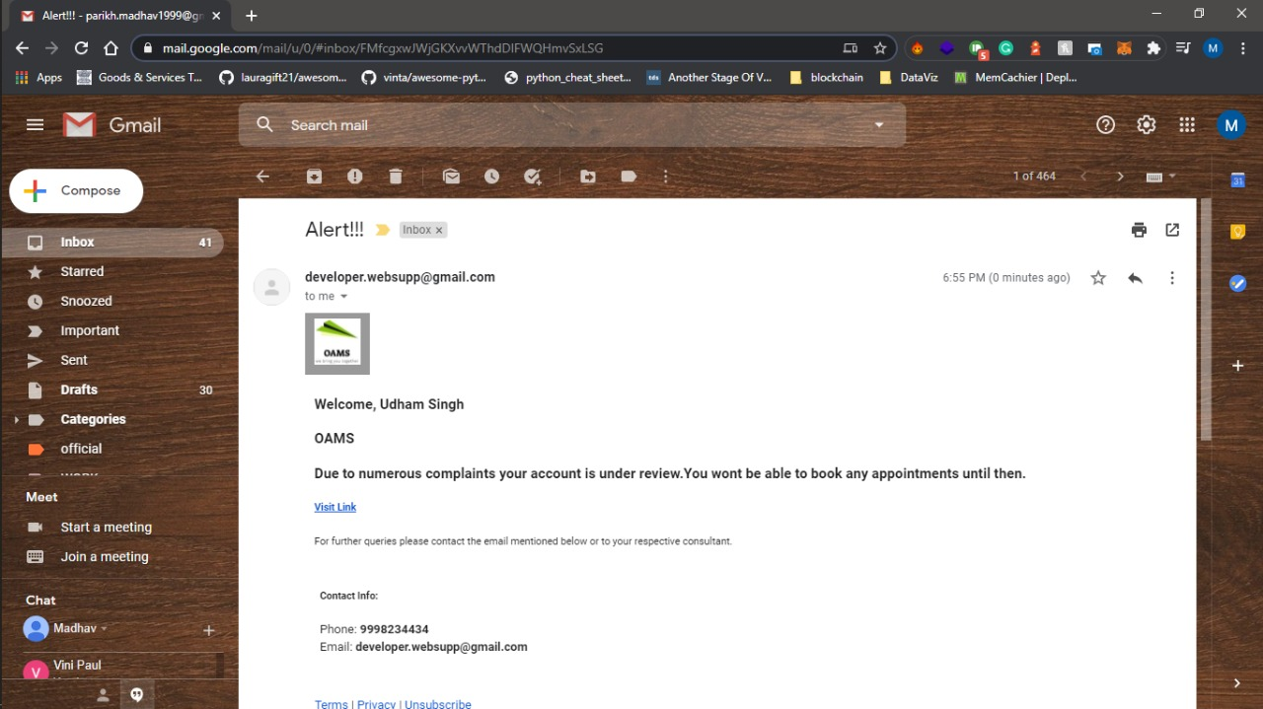

**Email received for action taken on user against the complaints on him**

Email received by the user after the admin has Deactivated his account from the Verify user panel because of the complaints registered on him.

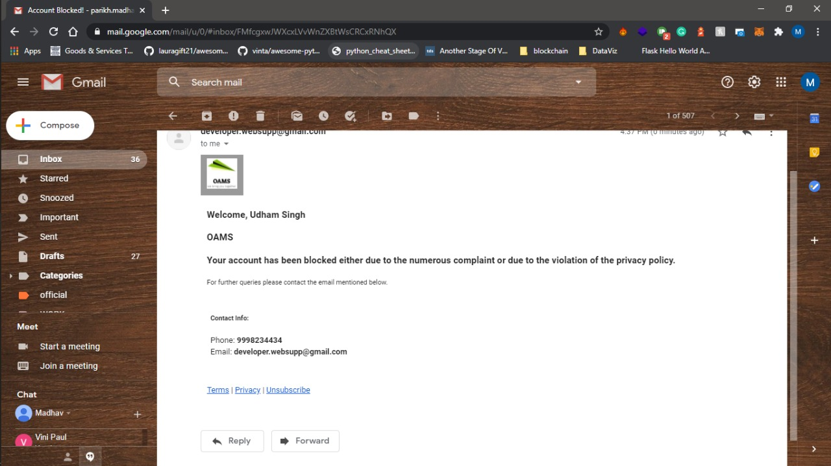

**Email received by the user for rescheduled appointments**

This is the email received by the user when the consultant reschedule the appointment.

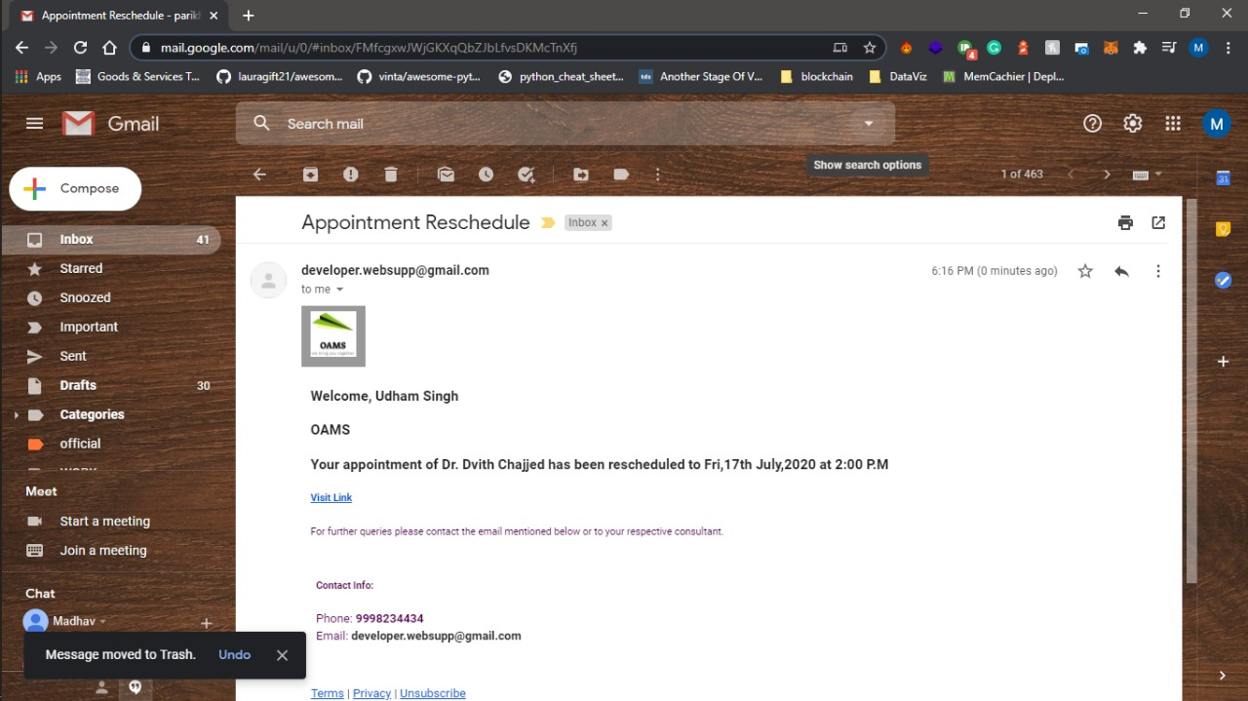

**REPORTS LAYOUTS**

**Appointment wise reports**

It shows the number of appointments made by consultants.

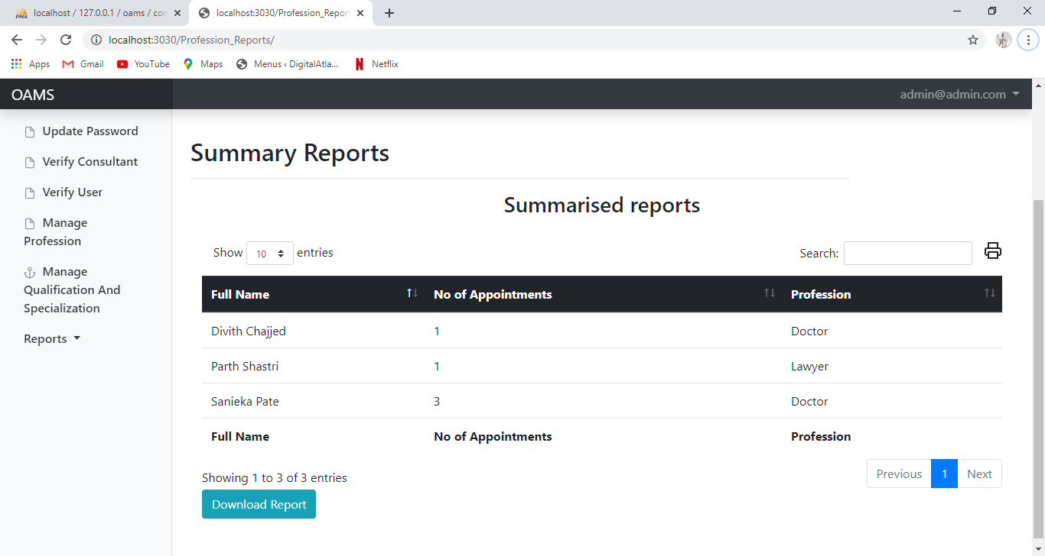

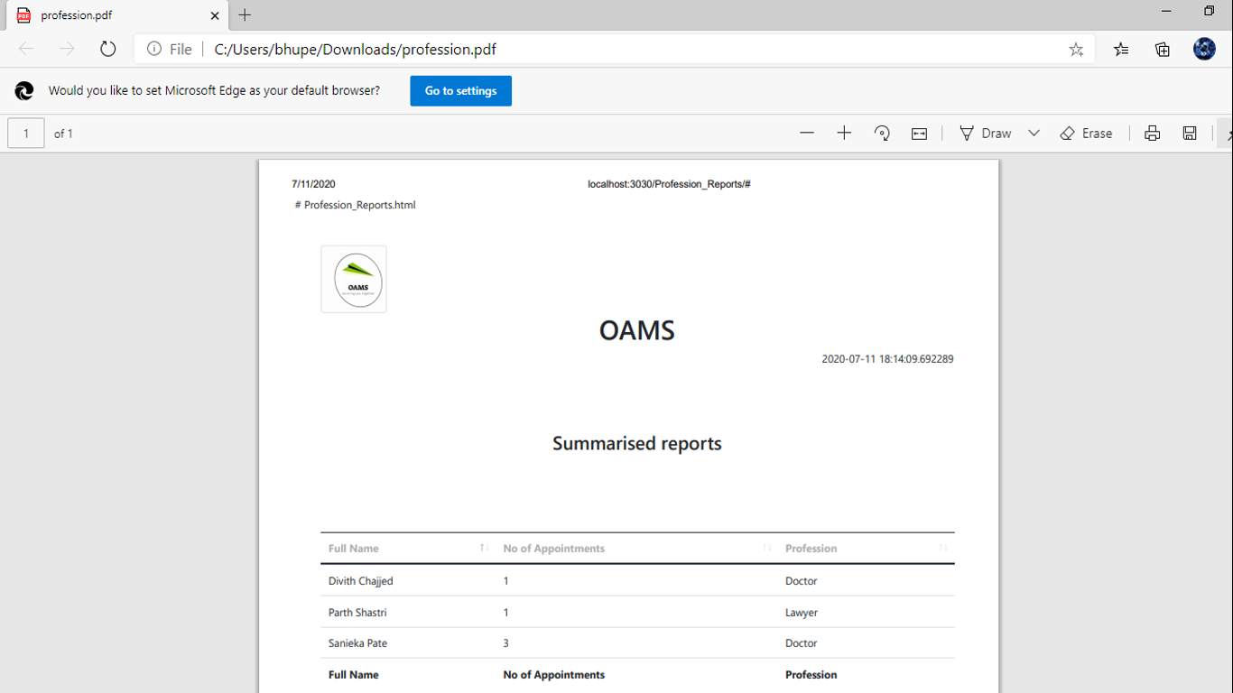

**Location wise reports**

It shows the details of the consultant by feeding information such as Area name,city and state.

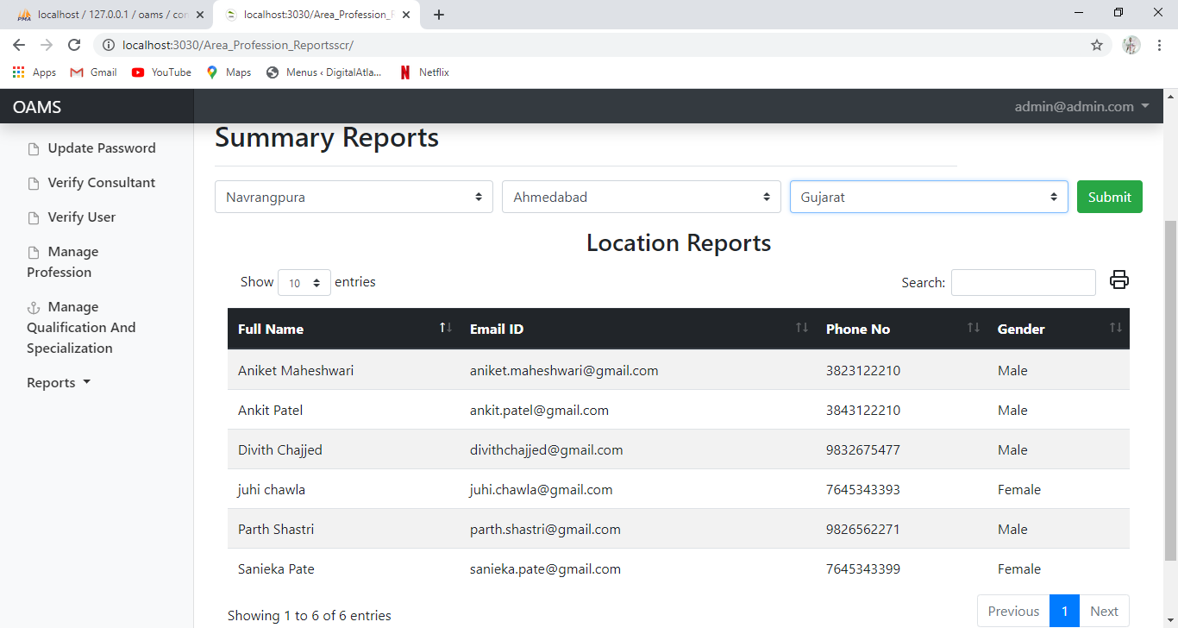

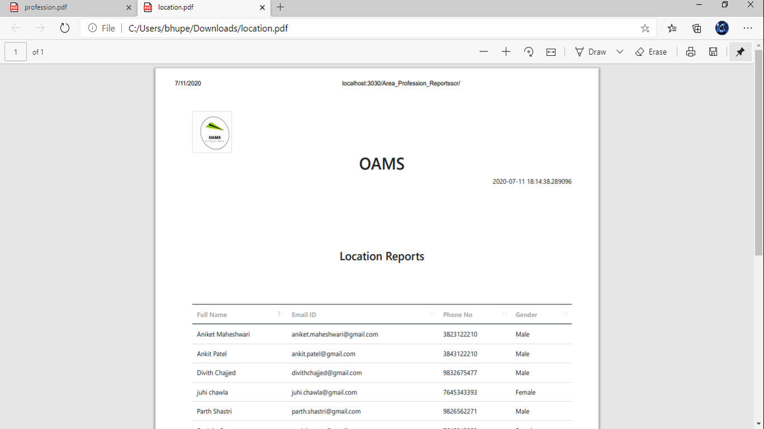

**Date wise reports**

It will show the number of appointments of the consultants from a date range showing name ,profession and appointment.

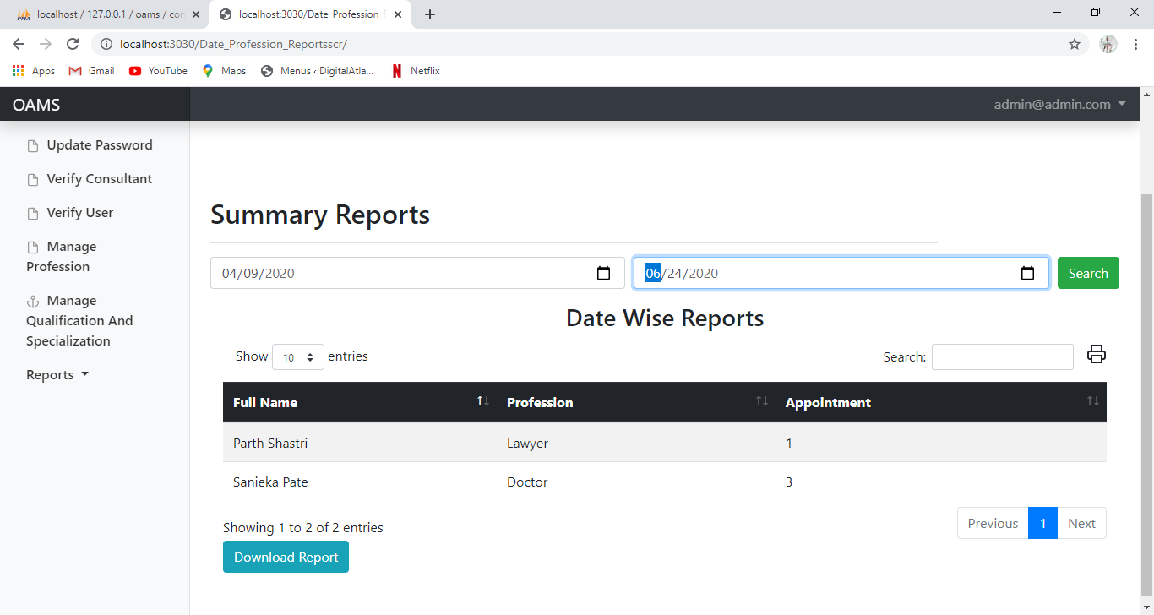

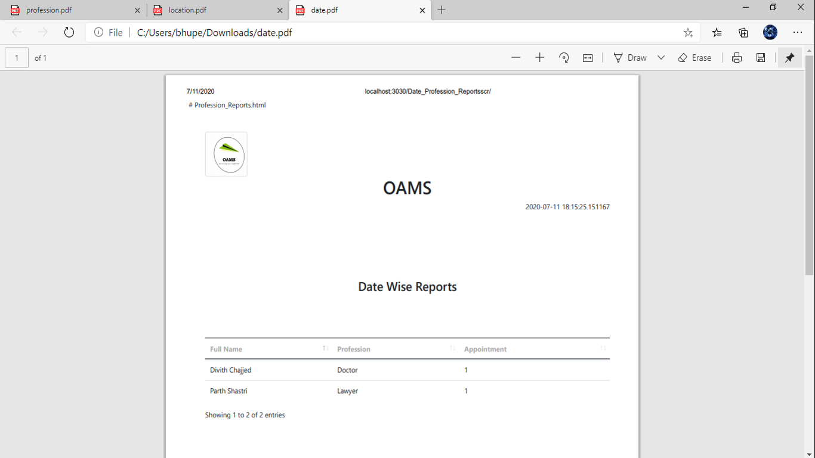

**Experience wise reports**

It shows the experience of all the consultants irrespective of profession.

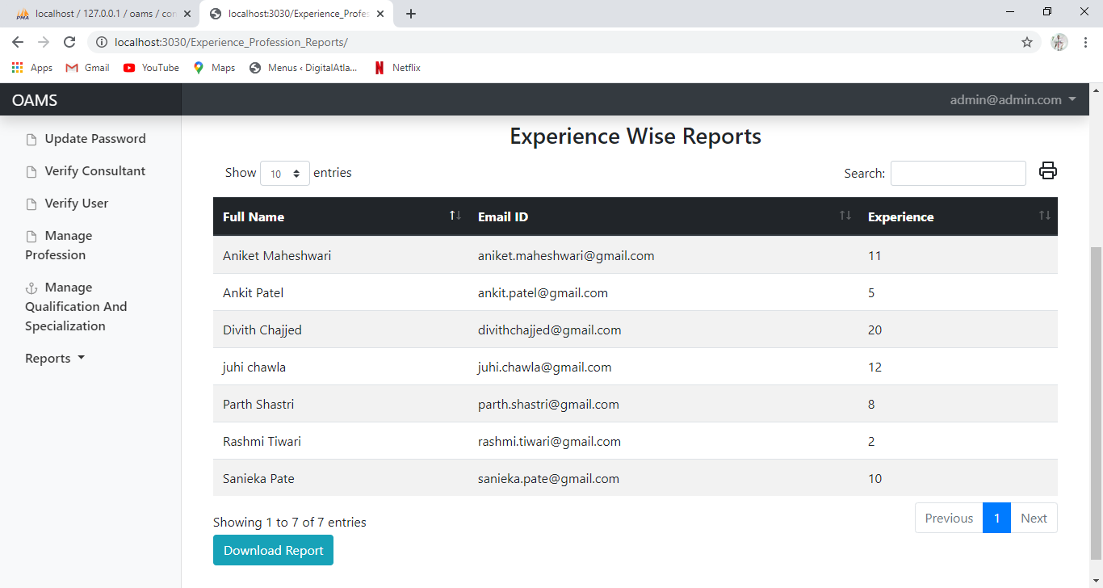

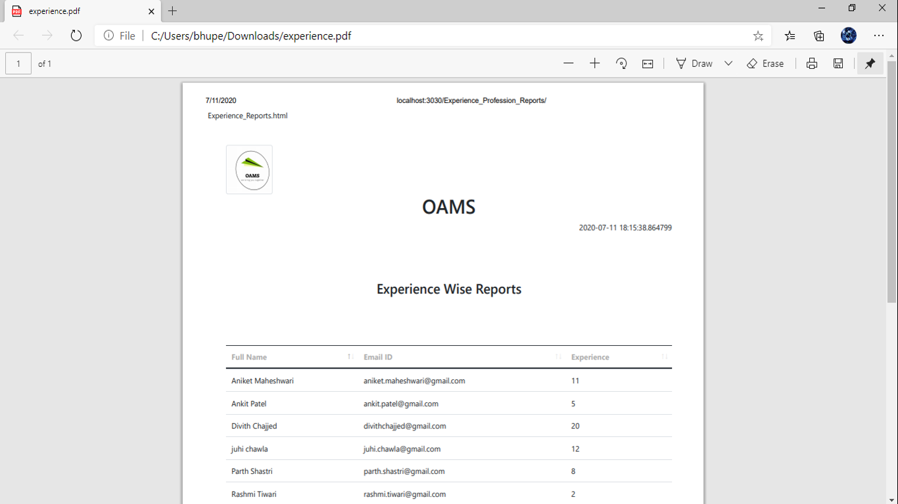

**Feedback wise reports**

It shows the average ratings as well as number of reviews of consultants.

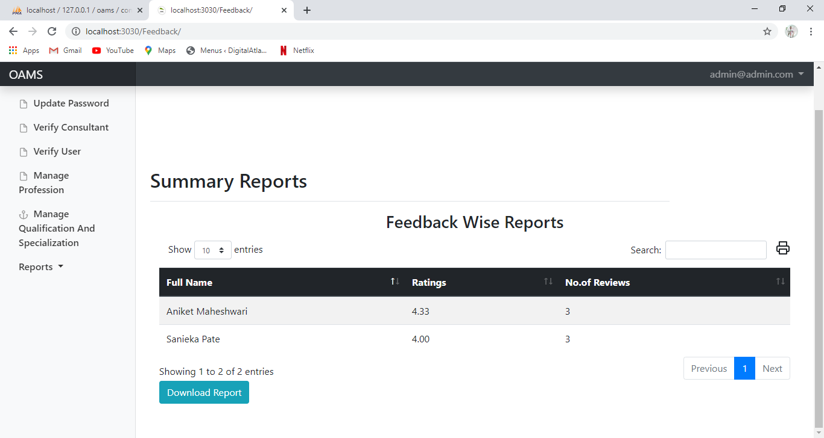

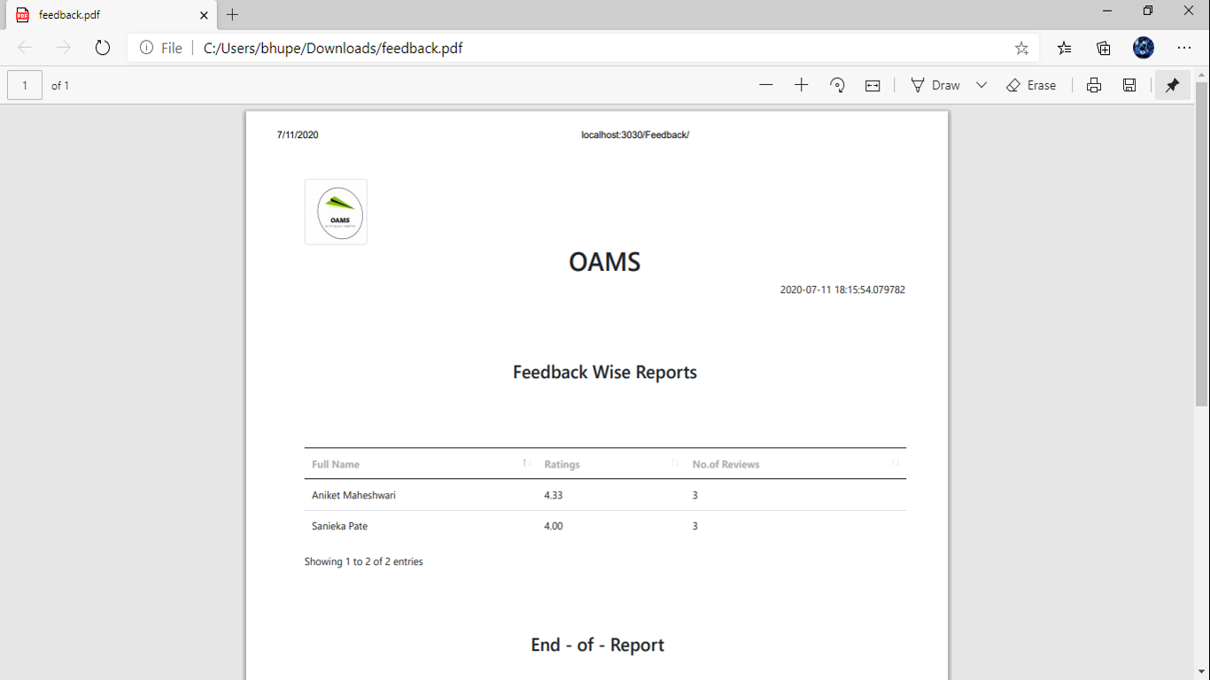

**Area profession and specialization wise reports**

It shows the Name,email ID,City,Profession as per the area, profession type and specialization .

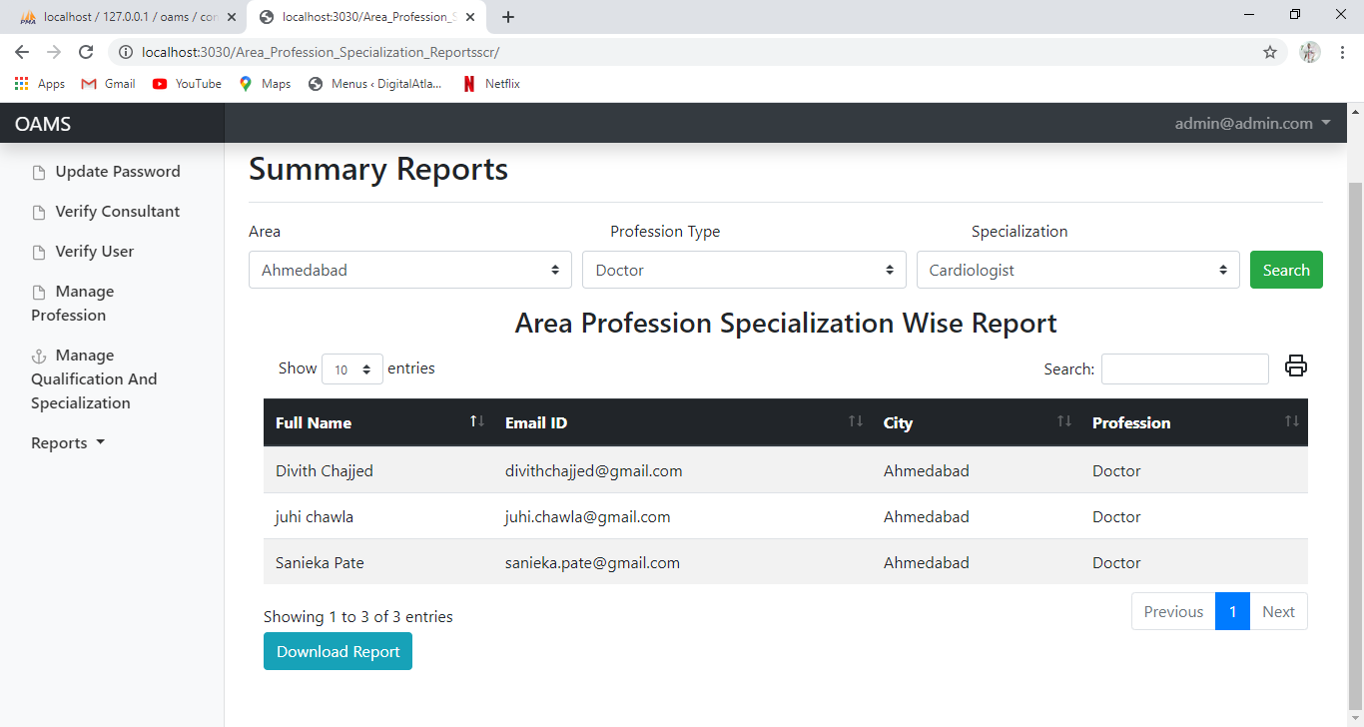

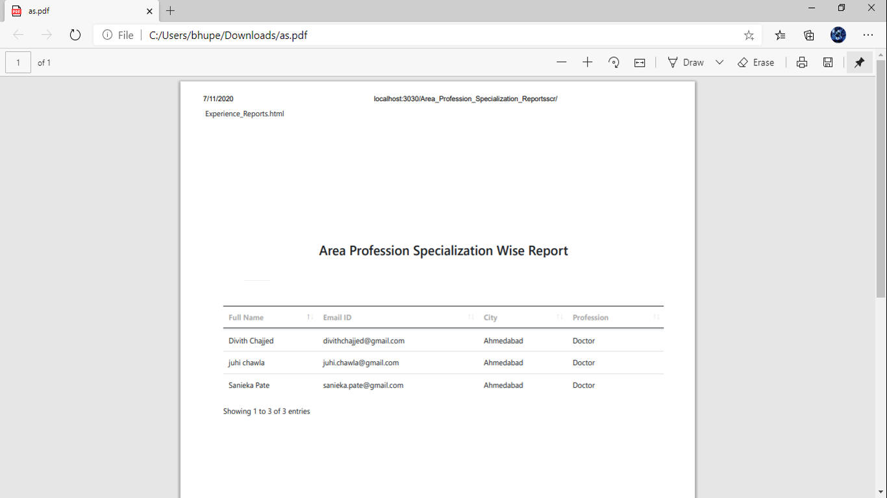

**Area Profession and Experience wise reports**

It shows the experience reports according to the Area,Profession Type,and specialization.

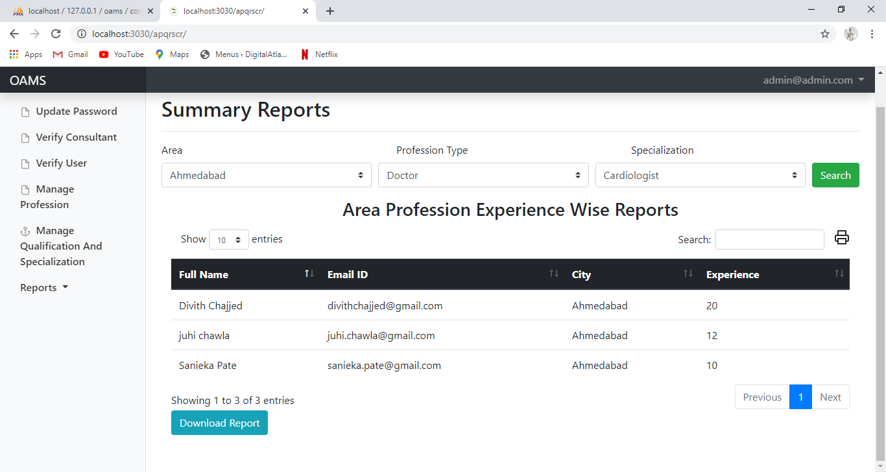

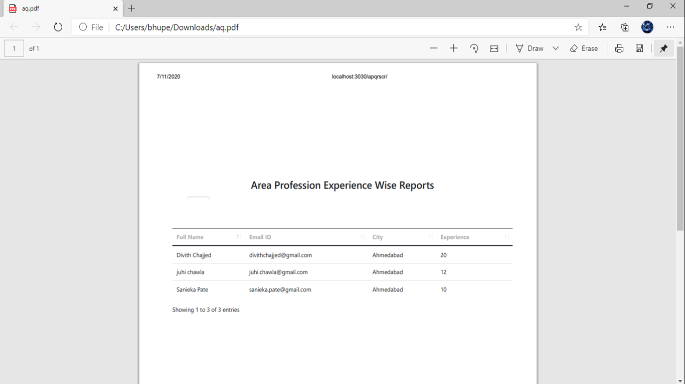

**CONCLUSION**

The whole duration of this project has been a great learning experience for us. It has introduced us more to the working of the real world projects and the problems that we face while developing them.

By development of this website, we here by conclude that at OAMS (Online appointment management system) we have achieved our aim at creating a platform where we have created and promoted a healthy environment for the interaction of the community of Consultants and Clients.

We also conclude that our project makes it easy for the Clients to register a appointment to the consultant as per his needs and he can also reschedule or cancel it. Clients can upload his other medical reports and consultant can view those reports. Consultant can also view his appointments and he can also choose whether he want to take that appointment or not.

We have also integrated a SMS notification system with our website so whenever a user have its appointment he will get a SMS notification on his registered mobile number two hours prior to the appointment time.

We also hope to expand the scale of the project and make it ubiquitous by developing it for all digital platforms.

**BIBLIOGRAPHY**

**Book references:**

* + Magnifying Object-Oriented Analysis & Design
  + Publisher: PHI Learning Publication

**Website references:**

* + Tutorialspoint: https://tutorialspoint.com/
  + Stackoverflow: https://stackoverflow.com/
  + Medium: <https://medium.com/>

 